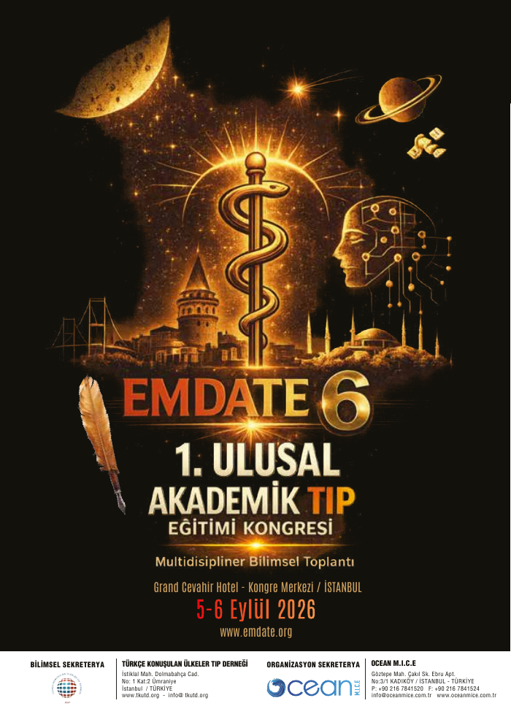
EMDATE 6

TAM METİN SÖZLÜ BİLDİRİLER KİTABI
Full Text Oral Proceedings
1. Ulusal Akademik Tıp Eğitimi Kongresi
5–6 Eylül 2026 · Grand Cevahir Kongre Merkezi · İstanbul
Bilim ve Yayın Kurulları onaylı nihai yayın sürümü · 23 Ekim 2026

YAYIN KÜNYESİ / PUBLICATION INFORMATION
Eser / Publication: EMDATE 6 — Tam Metin Sözlü Bildiriler Kitabı / Full Text Oral Proceedings
Toplantı / Congress: 1. Ulusal Akademik Tıp Eğitimi Kongresi (EMDATE 6)
Kongre tarihi ve yeri: 5–6 Eylül 2026, Grand Cevahir Hotel — Kongre Merkezi, İstanbul, Türkiye
Bildiri oturumu / Oral session: Cumartesi 5 Eylül 2026, 16.00–16.30, B Salonu
Oturum başkanları / Session chairs: Doç. Dr. Ömerul Faruk AYDIN; Dr. Öğr. Üyesi Mehmet TATLI
Yayın değerlendirmesi / Scientific review: EMDATE 6 Bilim Kurulu ve Yayın Kurulunun değerlendirmesiyle kabul edilmiş tam metin sözlü bildiriler.
Bilimsel iş birliği (yalnız EMDATE 6): Türkçe Konuşulan Ülkeler Tıp Derneği (TKUTD).
Yayın sürümü / Edition: 1.0 — 23 Ekim 2026 tarihli kurul onaylı nihai dosya; çevrimiçi yayımlanma tarihi web sunucusuna ilk yükleme tarihinde kesinleşir.
Erişim: EMDATE 6 kongre arşivi — https://emdate.net/emdate6/tam-metin-bildiriler (FTP kurulumu sonrasında etkinleşir).
Bibliyografik kimlik: ISBN, e-ISBN ve DOI henüz tahsis edilmiş belgeyle bildirilmediğinden bu sürüme eklenmemiştir.
Yayın türü: Ulusal kongrede sözlü olarak sunulmuş ve tam metin halinde derlenmiş konferans bildirileri; dergi makalesi veya uluslararası kongre yayını olarak nitelendirilmez.
Beyan: Tam metinlerdeki etik/onam, çıkar çatışması, finansman ve klinik içerik bildirimleri kaynak metinlerde sunulduğu kapsamda korunmuştur. SS-002 beş olguluk klinik olgu serisi olarak değerlendirilmiş, etik kurul gerekliliği hakkındaki kongre kurulu değerlendirmesi kabul edilmiştir; bu değerlendirme başka çalışmalar için genel etik kurul muafiyeti oluşturmaz.

SUNUŞ / EDITORIAL PREFACE
EMDATE, hekimlerin bilimsel gelişimini, aktif eğitimini ve mesleki dayanışmasını destekleyen bir kongre geleneğidir. EMDATE 6, 5–6 Eylül 2026 tarihlerinde İstanbul’da gerçekleştirilen 1. Ulusal Akademik Tıp Eğitimi Kongresidir.
Bu eser, 5 Eylül 2026 Cumartesi günü B Salonu’ndaki sözlü bildiriler oturumunda sunulan SS-001–SS-007 kodlu yedi bilimsel eserin eksiksiz tam metinlerini içerir. Eserler program sırasına göre yayımlanmış, yazarların onaylı sıraları ile kürsüde sunum yapan kişiler ayrı alanlarda verilmiş; tablolar, klinik görüntüler ve kaynakçalar metinlerle birlikte korunmuştur.
Bilim ve Yayın Kurulları tarafından değerlendirilen bu nihai sürümde SS-005 için Gülendam Alkan — Esat Barut ve SS-007 için İbrahim Halil Yasak — Ahmet Ocak — Fatma Taş yazar sıraları esas alınmıştır. Her iki bildiriyi sırasıyla Gülendam Alkan ve Ahmet Ocak sunmuştur. Konuşmayı yapan kişinin ilk yazar olması şart değildir.
Akademik kullanım notu: Doçentlik başvurularında eserlerin değerlendirilmesi, adayın başvuru tarihindeki ÜAK alan koşulları ve gerçek yayın/sunum belgelerine tabidir. Kitabın kendisi hakemli dergi yayını veya uluslararası toplantı belgesi yerine geçmez.

EMDATE 6 KONGRE KURULLARI

Kongre Bilim Kurulu
Ünvan ve ad soyad | Görev
Prof. Dr. Serkan Emre EROĞLU | Başkan
Doç. Dr. Ömerul Faruk AYDIN | Başkan Yardımcısı
Prof. Dr. Gürkan ERSOY | Üye
Prof. Dr. Birsen Pınar YILDIZ | Üye
Prof. Dr. Muhammed KESKİN | Üye
Doç. Dr. Burak KATİPOĞLU | Üye
Doç. Dr. Gökhan EYÜPOĞLU | Üye
Doç. Dr. Sarper YILMAZ | Üye
Dr. Öğr. Üyesi Erhan ARIKAN | Üye
Dr. Öğr. Üyesi Mehmet TATLI | Üye
Dr. Öğr. Üyesi Eren GÖKDAĞ | Üye
Uzm. Dr. Esra TEKİN | Üye
Doç. Dr. Serdar ÖZDEMİR | Üye
Uzm. Dr. Mert GÜLTEKİN | Üye

Kongre Düzenleme Kurulu
Ünvan ve ad soyad | Görev
Uzm. Dr. Ayşegül İŞLEK YÜKSEL | Başkan
Uzm. Dr. Bora KAYA | Üye
Uzm. Dr. Velihan ÇAYHAN | Üye
Uzm. Dr. Kübra BAĞCI | Üye
Uzm. Öğr. Ahmet OCAK | Üye
Dr. Ahmet ŞENEL | Üye
Uzm. Dr. Mert GÜLTEKİN | Üye
Kurullar kongreye ait bilimsel program verileri ve 23 Ekim 2026 tarihli yetkili ekleme talebi esas alınarak listelenmiştir.

ONAYLI SÖZLÜ BİLDİRİ OTURUMU / APPROVED SESSION
5 Eylül 2026 Cumartesi · B Salonu · 16.00–16.30
Oturum başkanları: Doç. Dr. Ömerul Faruk AYDIN · Dr. Öğr. Üyesi Mehmet TATLI
Kod | Bildiri | Tam metin yazarları (onaylı sıra) | Sunumu yapan
SS-001 | Sedanter Yaşam ve Sosyal İzolasyon: Acil Tablolardan Kronik Hastalıklara Derinleşen Küresel Sağlık Krizi | Mehmet Gün | Mehmet Gün
SS-002 | Psikiyatrik Bulgularla Başvuran Otoimmün Ensefalit Olguları: Tanısal Güçlükler ve Klinik İpuçları | Duygu Özkan Yaşargün | Duygu Özkan Yaşargün
SS-003 | Çocukluk Çağı Travmaları ile Akciğer Kanseri ve Aracı Faktörler Arasındaki İlişki: Bir Klinik Vaka-Kontrol Çalışması | Hülya Abalı | Hülya Abalı
SS-004 | Upper Airway Edema Following Intranasal Ecballium elaterium: An Emergency Department Case | Talha Gökber Durmuş, Hasan Büyükaslan | Talha Gökber Durmuş
SS-005 | Kardiyopulmoner Arrest Sonrasında Tanı Konulan Özofagus Perforasyonu: Olgu Sunumu | Gülendam Alkan, Esat Barut | Gülendam Alkan
SS-006 | From Low Back Pain to Paraplegia | İlhami Yüksel, Hasan Büyükaslan | İlhami Yüksel
SS-007 | Postpartum Kardiyomiyopati Sonrasında Gelişen Serebral Venöz Tromboz, İntraserebral Kanama ve Akut Pulmoner Ödem: Nadir Görülen Bir Olgu | İbrahim Halil Yasak, Ahmet Ocak, Fatma Taş | Ahmet Ocak
Oturum başkanları ve onaylı yazar/sunucu ayrımı bilimsel programın ilk basılı nüshasına sonradan işlenmiş kongre kurulu düzeltmesidir. Tarihsel program nüshası kitabın sonunda korunmuştur.

İÇİNDEKİLER / TABLE OF CONTENTS
Kod | Tam metin bildirisi | Sayfa
SS-001 | Sedentary Living and Social Disconnection: A Hidden Catalyst of the Global Health Crisis | 11
SS-002 | Autoimmune Encephalitis Presenting with Psychiatric Symptoms: Diagnostic Challenges and Clinical Clues | 16
SS-003 | Impact of Adverse Childhood Experiences on Lung Cancer Risk and the Role of Mediating Factors: A Case-Control Study | 22
SS-004 | Upper Airway Edema Following Intranasal Ecballium elaterium: An Emergency Department Case | 31
SS-005 | Esophageal Perforation Diagnosed Following Cardiopulmonary Arrest: A Case Report | 34
SS-006 | From Low Back Pain to Paraplegia | 37
SS-007 | Cerebral Venous Thrombosis, Intracerebral Hemorrhage and Acute Pulmonary Edema Following Postpartum Cardiomyopathy: A Rare Case | 40
Yazar dizini ve kongrenin orijinal bilimsel programı kitabın sonunda yer almaktadır.

SS-001 — Sedentary Living and Social Disconnection: A Hidden Catalyst of the Global Health Crisis
Sedanter Yaşam ve Sosyal İzolasyon: Acil Tablolardan Kronik Hastalıklara Derinleşen Küresel Sağlık Krizi
Yazarlar / Authors (onaylı sıra): Mehmet Gün
Sunumu yapan / Presenting author: Mehmet Gün
Çalışma türü / Manuscript type: Anlatısal derleme / Narrative review
Bilim ve Yayın Kurullarının kabul ettiği tam metin. İçerik ve kaynakçalar gönderilen metinlere dayanır.
Title
Sedentary Living and Social Disconnection: A Hidden Catalyst of the Global Health Crisis
Author- Dr. Mehmet Gün
Affiliation Maltepe University Faculty of Medicine, Department of Emergency Medicine, Istanbul, Türkiye
Corresponding Author Dr. Mehmet Gün Şile State Hospital Istanbul, Turkey Email: mehmet.gun@maltepe.edu.tr
The author declares no conflicts of interest.
No funding was received for this study.
No real patient data were used; therefore, ethical approval was not required.
This manuscript has not been previously published and is not under consideration for publication elsewhere.
Sedentary Living and Social Disconnection: A Hidden Catalyst of the Global Health Crisis
Abstract
Background: Sedentary behavior and social disconnection are increasingly recognized as important and potentially modifiable contributors to the global burden of chronic disease and poor mental health. Modern lifestyles, digitalization, urban environments, and changing work patterns have contributed to reduced physical activity and social participation.
Methods: A narrative literature review was conducted using PubMed, Google Scholar, and World Health Organization databases. Relevant literature published between 2020 and 2026 was identified using terms related to sedentary behavior, physical inactivity, social isolation, loneliness, non-communicable diseases, mental health, and public health. Relevant peer-reviewed studies, systematic reviews, meta-analyses, and international health reports were synthesized.
Results: Globally, approximately 1.8 billion adults are insufficiently physically active, while more than 1 billion people are living with obesity. Insufficient physical activity is associated with cardiovascular disease, type 2 diabetes, cancer, reduced mobility, and premature mortality. Social isolation and loneliness are associated with depression, anxiety, cognitive decline, cardiovascular risk, and increased mortality. The coexistence of these factors may compound health risks and contribute to clinical presentations requiring medical evaluation, including acute exacerbations of chronic cardiometabolic and mental health conditions.
Conclusion: Sedentary living and social disconnection represent interconnected public health challenges extending from chronic disease prevention to clinical and acute care settings. Addressing these risks requires coordinated strategies involving active urban design, physical activity promotion, social participation, community-based interventions, and the integration of lifestyle and social determinants of health into primary care, medical education, and public health policies.
Özet
Giriş ve Amaç: Sedanter davranış ve sosyal kopukluk, kronik hastalık yükü ve kötü ruh sağlığına katkıda bulunan, giderek daha fazla önem kazanan ve değiştirilebilir halk sağlığı sorunlarıdır. Modern yaşam biçimleri, dijitalleşme, kentsel çevreler ve değişen çalışma düzenleri fiziksel aktivitenin ve sosyal katılımın azalmasına katkıda bulunmaktadır.
Yöntem: Bu anlatısal derlemede PubMed, Google Scholar ve Dünya Sağlık Örgütü (DSÖ) veri tabanları kullanılarak 2020–2026 yılları arasında yayımlanan ilgili literatür taranmıştır. Aramalarda sedanter davranış, fiziksel inaktivite, sosyal izolasyon, yalnızlık, bulaşıcı olmayan hastalıklar, ruh sağlığı ve halk sağlığı ile ilişkili anahtar kelimeler kullanılmıştır. Konuyla ilişkili hakemli çalışmalar, sistematik derlemeler, meta-analizler ve uluslararası sağlık raporları değerlendirilmiştir.
Bulgular: Küresel olarak yaklaşık 1,8 milyar yetişkinin yeterli düzeyde fiziksel aktivite yapmadığı, 1 milyardan fazla kişinin ise obezite ile yaşadığı bildirilmektedir. Yetersiz fiziksel aktivite; kardiyovasküler hastalık, tip 2 diyabet, kanser, hareket kısıtlılığı ve erken mortalite ile ilişkilidir. Sosyal izolasyon ve yalnızlık ise depresyon, anksiyete, bilişsel gerileme, kardiyovasküler risk ve artmış mortalite ile ilişkilendirilmektedir. Bu faktörlerin birlikte bulunması sağlık risklerini artırabilir ve kardiyometabolik hastalıkların akut alevlenmeleri ile ruhsal sağlık sorunları dahil olmak üzere tıbbi değerlendirme gerektiren klinik başvurulara katkıda bulunabilir.
Sonuç: Sedanter yaşam ve sosyal kopukluk, kronik hastalıkların önlenmesinden klinik ve acil bakım süreçlerine kadar uzanan, birbiriyle ilişkili halk sağlığı sorunlarıdır. Bu risklerin azaltılması; aktif kentsel tasarım, fiziksel aktivitenin teşvik edilmesi, sosyal katılımın artırılması, toplum temelli müdahaleler ve yaşam tarzı ile sosyal belirleyicilerin birinci basamak sağlık hizmetlerine, tıp eğitimine ve halk sağlığı politikalarına entegre edilmesini içeren koordineli stratejiler gerektirmektedir.
1.Introduction
In today's hyper-connected yet physically inactive world, people move less than ever before. Lifestyle changes have replaced many forms of daily physical activity. Meals are delivered rather than prepared. Entertainment is streamed instead of experienced in public spaces like cinemas. Children play indoors on screens rather than outdoors with peers. Even physical activity is increasingly confined to home fitness routines, or, for many, neglected altogether. This shift, while efficient, fuels a lifestyle that is both sedentary and socially isolating [1]. According to the World Health Organization (2024), over 1.8 billion adults globally are at risk of developing chronic conditions due to insufficient physical activity [2].
These lifestyle-driven health burdens extend beyond obesity to include cardiovascular disease, diabetes, and other non-communicable diseases. At the same time, rising levels of social isolation—particularly among youth and older adults—are associated with depression, anxiety, cognitive decline, cardiovascular risk, and even premature mortality . Together, sedentary behavior and social disconnection form a dual public health challenge, reinforcing one another and amplifying risks to physical, mental, and societal well-being [3,4].
Sedentary behavior and social isolation are not only the result of personal choices but are also shaped by factors such as digitalization, urban design, and modern work patterns [5]. These factors are often linked to making inactivity and isolation more prevalent aspects of daily life. Physical inactivity and social isolation have often been studied separately in public health, but today they increasingly overlap and, when considered together, represent a significant risk factor for population health.
However, the impact of these factors is not uniform across societies. The drivers and health consequences of sedentary behavior and social isolation differ depending on socioeconomic status, cultural norms, and geography[6]. In high-income cities, sedentary behavior is often linked to technology use and office-based occupations, whereas in low- and middle-income regions, it may be more associated with limited access to safe public spaces or cultural restrictions on outdoor activities. Evidence also indicates that individuals experiencing social isolation are more likely to engage in sedentary lifestyles and less likely to maintain regular physical activity, compounding health risks[7.] At the same time, urban environments reveal striking inequities, with social and structural conditions amplifying vulnerabilities in certain populations. Similarly, social isolation can look different across societies, driven by aging populations in some regions, and by urban migration or economic hardship in others. However, current research still largely reflects high-income contexts, with less attention to the diversity of experiences in lower-resource environments.
This review aims to synthesize recent evidence on sedentary living and social isolation as converging determinants of the global health crisis. It moves beyond fragmented findings to underscore the urgent need for prevention strategies and public health policies that simultaneously address this dual risk.

2.Methods
This study was conducted as a narrative review. The aim was to synthesize recent evidence on sedentary behavior and social isolation as dual determinants of global health.
Relevant sources were identified through targeted searches of PubMed, Google Scholar, and the World Health Organization (WHO) online databases. Search terms included: “sedentary behavior,” “sedentary lifestyles,” “physical inactivity,” “social isolation,” “social disconnection,” “loneliness,” “non-communicable diseases,” “obesity,” “cardiovascular disease,” “hypertension,” “type 2 diabetes,” “cancer,” “mental health,” “depression,” “anxiety,” “sleep disturbances,” “cognitive decline,” “Alzheimer’s disease,” “premature mortality,” “digitalization,” “urban design,” “active transport,” “remote work,” “public health policy,” and “urban environments.”
The search was limited to publications between 2020 and 2025, in order to capture post-pandemic lifestyle trends and the most up-to-date global health reports. Priority was given to peer-reviewed journal articles, systematic reviews, meta-analyses, and WHO publications. Reference lists of selected articles were also screened to identify additional relevant sources.
As this was not a systematic review, no formal inclusion or exclusion criteria were applied. Instead, studies were included based on their relevance to the thematic scope of the paper, with emphasis on evidence linking sedentary behavior and social disconnection to physical, mental, and societal health outcomes. The review also integrated policy-oriented reports to highlight implications for prevention and intervention.
3. Review of the Evidence
3.1.The Scope of the Crisis
Sedentary lifestyles and social disconnection are often overlooked as root causes of the global health crisis. These behaviors have quietly intensified over the past two decades, particularly with the advent of mobile technology, remote work, and urban environments that deprioritize active living. According to the World Health Organization (2024), more than 1 billion people globally are living with obesity, including approximately 890 million adults. Among children and adolescents aged 5–19, obesity rates have quadrupled since 1990. This epidemic is driven not only by calorie surplus but also by an alarming lack of daily physical movement[8].
Beyond obesity, sedentary living and social isolation also affect a wide range of health outcomes, including cardiovascular disease, type 2 diabetes, cancer, depression, Alzheimer’s disease and premature mortality[9]. According to the World Health Organization, around 4–5 million deaths per year could be averted if people were more physically active worldwide [10]. In addition, nearly 1.8 billion adults globally are now at risk of preventable diseases due to insufficient physical activity [2]. Recent global estimates show that about 31% of adults and 80% of adolescents fail to meet recommended activity levels, underlining the persistence of inactivity as a leading risk factor [11]. At the same time, social isolation and loneliness are consistently linked to poor health outcomes, with pooled analyses of more than 90 cohort studies showing a 1.32-fold increased risk of premature mortality among socially isolated individuals [12]. Taken together, these findings highlight that the scope of the crisis extends far beyond obesity, encompassing both physical and psychological health burdens.
3.2 Psychosocial and Mental Health Consequences
Social isolation contributes to increased rates of depression and anxiety, both of which are well-established mental health outcomes. The World Health Organization (2021) identifies social isolation as a growing concern, especially among older adults and youth who spend more time interacting with screens than peers [13]. It is also strongly associated with sleep disturbances and suicidal behavior, further highlighting its psychological impact. In addition to these mental health consequences, social isolation has been linked to cognitive decline and Alzheimer’s disease, outcomes that are more accurately understood as neurological in nature, particularly in aging populations [14]. Loneliness and disconnection are now recognized as behavioral risk factors that compromise both mental health and neurological integrity [15].
3.3 Physical Health Outcomes
Prolonged inactivity affects metabolic function, circulation, musculoskeletal strength, and immune resilience. It contributes to obesity, type 2 diabetes, hypertension, and several forms of cancer, underscoring its role as a major public health concern [9,16]. The interplay between inactivity and poor mental health creates a reinforcing cycle that undermines both physical and emotional well-being [17].
3.4 Underlying Causes
- Increased reliance on digital services and entertainment
- Urban design that deprioritizes walking and active transport
- Normalization of remote work and home-based leisure
- Sedentary behavior becoming culturally accepted
- Limited public awareness of the health risks associated with inactivity and isolation
4. Public Health and Economic Implications
The economic burden of lifestyle-driven health issues is immense. Rising rates of chronic disease result in higher healthcare costs, reduced workforce productivity, and increased disability. The World Health Organization (2024) highlights the need for urgent multi-sectoral policies to promote physical activity, redesign cities for movement, and reintegrate social connection into public life.
5. Recommendations and Solutions
- Promote active urban infrastructure (parks, bike paths, pedestrian zones)
- Integrate movement breaks and social engagement in schools and workplaces
- Launch public awareness campaigns about sedentary risks and social disconnection
- Monitor physical activity levels in primary care screenings
- Support grassroots community activities that foster physical and social participation [18,19].
6. Policy Implications The growing overlap between sedentary living and social isolation highlights the need for coordinated health policies that go beyond individual behavior change. National governments and local authorities are encouraged to prioritize active urban design, support school and workplace programs that integrate physical activity with social participation, and fund community initiatives that reduce loneliness. Embedding these priorities into existing non-communicable disease prevention strategies could help reduce long-term healthcare costs, improve quality of life, and create healthier, more connected societies.
However, while these recommendations are valuable, their applicability is not universal, as their implementation may face significant limitations. Active urban planning or community-based programs are more feasible in high-income countries, where resources and infrastructure already exist. In contrast, low- and middle-income settings may face barriers such as limited budgets, the lack of safe public spaces, and cultural constraints. Policymakers should therefore adapt interventions to local conditions to ensure that strategies are realistic, equitable, and sustainable.
The key risks, strategies, and barriers are summarized in Table 1, while their interrelations are illustrated in Figure 1.

7.Limitations
This study has several limitations. First, it is a narrative review and not a systematic one, which limits the strength of its conclusions. Second, most of the available studies are from high-income countries, so the findings may not fully reflect the situation in low- and middle-income settings. Third, the recommendations proposed here may be difficult to implement in practice, especially in resource-limited contexts, due to financial, infrastructural, and cultural barriers.
8. Conclusion
Sedentary living and social disconnection are interlinked contributors to a growing global health crisis. Their cumulative impact is reflected in rising rates of non-communicable diseases, mental health disorders, and societal fragmentation. This review underscores the urgent need to recognize and address these behavioral risks within the global health policy agenda. Future research should prioritize community-level strategies that simultaneously promote physical activity and meaningful social participation across the life course.

9. Declaration
The author conducted the conception, design, evaluation, and writing of this study independently. The author declares no conflicts of interest. No funding was received for this study. No real patient data were used; therefore, ethical approval was not required. Consent to Publish declaration: not applicable. Consent to Participate declaration: not applicable. This manuscript has not been previously published and is not under consideration for publication elsewhere.
References
1. World Health Organization. Social isolation and loneliness among older people: advocacy brief. Geneva: World Health Organization; 2021.
2. World Health Organization. Nearly 1.8 billion adults at risk of disease from insufficient physical activity. WHO News. 2024 Jun 26. Available from: https://www.who.int/news/item/26-06-2024-nearly-1.8-billion-adults-at-risk-of-disease-from-not-doing-enough-physical-activity
3. Cené CW, Beckie TM, Sims M, et al. Effects of objective and perceived social isolation on cardiovascular and brain health: a scientific statement from the American Heart Association. J Am Heart Assoc. 2022;11(16):e026493. https://doi.org/10.1161/JAHA.122.026493
4. Holt-Lunstad J. Social connection as a critical factor for mental and physical health: evidence, trends, challenges, and future implications. World Psychiatry. 2024;23(3):312-22. https://doi.org/10.1111/wps.13328
5. Stappers NEH, Bekker MPM, Jansen MWJ, et al. Effects of major urban redesign on sedentary behavior, physical activity, active transport and health-related quality of life in adults. BMC Public Health. 2023;23(1):1157. https://doi.org/10.1186/s12889-023-16277-x
6. Werneck AO, Araujo RH, Oyeyemi AL, Silva DR. Social isolation is associated with higher leisure-time sedentary behavior and lower physical activity practice: a multi-country analysis of data from 79 countries from the Global School-Based Student Health Survey. Prev Med. 2023;175:107677. https://doi.org/10.1016/j.ypmed.2023.107677
7. Cacciatore S, Mao S, Nuñez MV, et al. Urban health inequities and healthy longevity: traditional and emerging risk factors across the cities and policy implications. Aging Clin Exp Res. 2025;37(1):143. https://doi.org/10.1007/s40520-024-02685-z
8. World Health Organization. Obesity and overweight. WHO Fact Sheet. 2024. Available from: https://www.who.int/news-room/fact-sheets/detail/obesity-and-overweight
9. Duncan MJ, Murphy L, Oftedal S, et al. The associations between physical activity, sedentary behaviour, and sleep with mortality and incident cardiovascular disease, cancer, diabetes and mental health in adults: a systematic review and meta-analysis of prospective cohort studies. J Activity Sedentary Sleep Behav. 2023;2(1):19. https://doi.org/10.1186/s43152-023-00019-y
10. World Health Organization. Physical activity. Geneva: WHO; 2024. Available from: https://www.who.int/health-topics/physical-activity
11.Strain T, Wijndaele K, Garcia L, et al. National, regional, and global trends in insufficient physical activity among adults from 2000 to 2022, with projections to 2030: a systematic analysis of the Global Burden of Disease Study. Lancet Glob Health. 2024;12(6):e894–906.
12. Wang F, Gao Y, Han Z, Yu Y, Long Z, Jiang X, et al. A systematic review and meta-analysis of 90 cohort studies of social isolation, loneliness and mortality. Nat Hum Behav. 2023;7(8):1307–19.
13. World Health Organization. Social isolation and loneliness among older people: advocacy brief. Geneva: World Health Organization; 2021.
14. Shafighi K, Villeneuve S, Rosa Neto P, et al. Social isolation is linked to classical risk factors of Alzheimer’s disease-related dementias. PLoS One. 2023;18(2):e0280471.
15.Holt-Lunstad J. Social connection as a critical factor for mental and physical health: evidence, trends, challenges, and future implications. World Psychiatry. 2024;23(3):312-22.
16. Kerr NR, Booth FW. Contributions of physical inactivity and sedentary behavior to metabolic and endocrine diseases. Trends Endocrinol Metab. 2022;33(12):817–27.
17. Chang de Pinho I, Giorelli G, Oliveira Toledo D. A narrative review examining the relationship between mental health, physical activity, and nutrition. Discov Psychol. 2024;4(1):162
18. Jacob CM, Hardy-Johnson PL, Inskip HM, Morris T, Parsons CM, Barrett M, et al. A systematic review and meta-analysis of school-based interventions with health education to reduce body mass index in adolescents aged 10 to 19 years. Int J Obes (Lond). 2022;46(5):811–20.
19. Wolbring L, Schmidt SCE, Niessner C, Woll A, et al. Community networks of sport and physical activity promotion: an analysis of structural properties and conditions of cooperation. BMC Public Health. 2022;22(1):268.
Table 1. Key Risks, Strategies, and Barriers Related to Sedentary Behavior and Social Isolation
Domain | Main Risks | Proposed Strategies | Potential Barriers
Sedentary Lifestyle | Obesity, cardiovascular disease, type 2 diabetes, cancer, and reduced mobility. | Promote physical activity through urban planning, provide activity breaks in schools and workplaces, and launch public awareness campaigns. | Urban designs that deprioritize active transport, limited public awareness, and the cultural acceptance of sedentary lifestyles.
Social Isolation | Depression, anxiety, cognitive decline, cardiovascular risk, and premature mortality. | Increase social participation in schools and workplaces, and support community initiatives that reduce loneliness. | Lack of safe public spaces, stigma, and unequal access to resources.
Modern Lifestyle Patterns | High screen time, irregular sleep, and unhealthy diet. | Promote multi-sectoral policies for physical activity, and redesign cities for movement. | Over-reliance on digital services and entertainment.
Public Health & Economic Implications | Higher healthcare costs, reduced workforce productivity, and increased disability rates. | Recommendations aim to reduce long-term healthcare costs and build healthier, more connected societies. | Limited budgets, workforce shortages, and infrastructural deficiencies.
Table 1. Summary of the main risks, strategies, and barriers related to sedentary behavior and social isolation. The table highlights how lifestyle factors and systemic conditions contribute to health outcomes and the importance of multi-sectoral interventions.

SS-002 — Autoimmune Encephalitis Presenting with Psychiatric Symptoms: Diagnostic Challenges and Clinical Clues
Psikiyatrik Bulgularla Başvuran Otoimmün Ensefalit Olguları: Tanısal Güçlükler ve Klinik İpuçları
Yazarlar / Authors (onaylı sıra): Duygu Özkan Yaşargün
Sunumu yapan / Presenting author: Duygu Özkan Yaşargün
Çalışma türü / Manuscript type: Beş olguluk olgu sunumu (olgu serisi) / Five-case clinical series
Bilim ve Yayın Kurullarının kabul ettiği tam metin. İçerik ve kaynakçalar gönderilen metinlere dayanır.
PSİKİYATRİK BULGULARLA BAŞVURAN OTOİMMÜN ENSEFALİT OLGULARI: TANISAL GÜÇLÜKLER VE KLİNİK İPUÇLARI
Duygu Özkan Yaşargün¹
¹ S.B.Ü. Haydarpaşa Numune Eğitim ve Araştırma Hastanesi, Nöroloji Kliniği, İstanbul, Türkiye
Sorumlu Yazar: Duygu Özkan Yaşargün · duyzkan01@gmail.com
Çalışma Türü | Dil | Kelime | Sayfa
Olgu | TR | 1715 | 5
ÖZET
Amaç: Otoimmün ensefalit, özellikle erken dönemde psikoz, davranış değişikliği, duygudurum bozukluğu ve bilişsel bozulma gibi psikiyatrik belirtilerle başlayabilmekte, bu nedenle primer psikiyatrik hastalıklarla karışarak tanıda gecikmeye yol açabilmektedir. Bu çalışmada psikiyatrik bulguların ön planda olduğu otoimmün ensefalit olgularının ortak klinik özelliklerinin ortaya konulması amaçlandı.
Yöntem: Kliniğimizde otoimmün ensefalit tanısı alan ve başlangıçta psikiyatrik yakınmalar nedeniyle değerlendirilen beş olgu retrospektif olarak incelendi. Klinik özellikler, MRG, EEG, BOS incelemeleri, otoantikor profilleri, tedavi ve klinik sonuçlar değerlendirildi.
Bulgular: Tüm olgularda başlangıçta psikiyatrik veya nöropsikiyatrik belirtiler ön plandaydı. İzlem sırasında nöbet, bilinç değişikliği, bilişsel kötüleşme, hareket bozukluğu, hiponatremi ve otonomik disfonksiyon gibi nörolojik bulgular gelişti. Olgular anti-NMDA reseptör ensefaliti, klinik LGI1 ensefaliti fenotipi, anti-GAD ilişkili ensefalit ve seronegatif limbik ensefalit spektrumunda değerlendirildi.
Sonuç: İlk psikotik atağa nöbet, bilişsel gerileme, hareket bozukluğu, otonomik bulgular veya tedaviye beklenmeyen yanıtsızlığın eşlik ettiği hastalarda otoimmün ensefalit akılda tutulmalıdır.
Anahtar Kelimeler: Otoimmün ensefalit, Anti-NMDA reseptör ensefaliti, Anti-LGI1 ensefaliti, Anti-GAD ensefaliti, Psikoz
Abstract
Background: Autoimmune encephalitis may initially present with psychiatric symptoms such as psychosis, behavioral changes, and cognitive impairment. Consequently, it may be mistaken for primary psychiatric disorders, leading to delays in diagnosis. This study aimed to identify the common clinical features of autoimmune encephalitis cases in which psychiatric manifestations were prominent.
Methods: Five patients diagnosed with autoimmune encephalitis at our clinic who were initially evaluated because of psychiatric symptoms were retrospectively reviewed. Clinical features, magnetic resonance imaging (MRI), electroencephalography (EEG), cerebrospinal fluid (CSF) findings, autoantibody profiles, treatment, and clinical outcomes were evaluated.
Results: Psychiatric or neuropsychiatric symptoms were prominent at presentation in all patients. During follow-up, neurological features including seizures, altered consciousness, cognitive decline, movement disorders, hyponatremia, and autonomic dysfunction emerged. The cases were classified within the spectrum of anti-NMDA receptor encephalitis, a clinical LGI1 encephalitis phenotype, anti-GAD-associated encephalitis, and seronegative limbic encephalitis.
Conclusion: Autoimmune encephalitis should be considered in patients presenting with a first psychotic episode, particularly when accompanied by seizures, cognitive decline, movement disorders, autonomic dysfunction, or an unexpected lack of response to treatment.
Keywords: Autoimmune encephalitis, anti-NMDA receptor encephalitis, anti-LGI1 encephalitis, anti-GAD encephalitis, psychosis

GİRİŞ
Otoimmün ensefalitler; psikiyatrik ve davranışsal değişiklikler, bilişsel bozulma, epileptik nöbetler, hareket bozuklukları ve otonomik disfonksiyonun farklı kombinasyonlarıyla seyreden heterojen bir hastalık grubudur. Özellikle nörolojik bulguların henüz belirginleşmediği erken dönemde primer psikiyatrik hastalıklarla karışabilir. Subakut seyir, yeni başlangıçlı nöbet, hızlı bilişsel kötüleşme, bilinç değişikliği, hareket bozukluğu, otonomik instabilite ve açıklanamayan hiponatremi otoimmün ensefalit açısından önemli klinik uyarıcılardır [1-3]. Tanı; klinik fenotip, BOS, EEG, MRG ve nöronal antikor sonuçlarının birlikte değerlendirilmesini gerektirir.

OLGU SUNUMU
Olgu 1: Yirmi yaşındaki kadın hasta bir haftadır uykusuzluk, irritabilite, persekütif düşünceler ve işitsel halüsinasyonlar nedeniyle psikiyatri servisine yatırıldı. Dördüncü günde konuşmada azalma, kooperasyon kaybı, inkontinans ve konvülzif nöbet gelişti. BOS’ta 40 hücre/mm³ (%60 mononükleer) ve Pandy pozitifliği saptandı. Kraniyal MRG artefakt nedeniyle suboptimal olmakla birlikte belirgin patoloji göstermedi. İzlemde jeneralize tonik-klonik nöbetler ve EEG’de yaygın organizasyon bozukluğu gelişti. Pelvik ultrasonografide sol adneksiyal kitle saptandı. BOS anti-NMDAR IgG pozitifliği ile anti-NMDAR ensefaliti tanısı doğrulandı. İntravenöz İmmünoglobulin (IVIG) ve pulse kortikosteroid tedavisine rağmen ağır otonomik instabilite gelişen hasta kardiyak arrest sonrası kaybedildi.
Olgu 2: Altmış bir yaşındaki kadın hasta depresif belirtiler, düşünce içeriğinin yavaşlaması ve paranoid düşünceler nedeniyle psikotik depresyon tanısıyla psikiyatri servisine yatırılmıştı. İzlemde jeneralize nöbetler gelişti ve serum sodyumu 97 mmol/L saptandı. Nöroloji kliniğine devrinde konfüze ve ajiteydi. İki adet BOS incelemesinde hücre sayısı 1/mm³ ve biyokimya normaldi; otoimmün/paraneoplastik antikor paneli negatifti. Tekrarlanan kraniyal MRG’de sol temporal lobun tamamında ve sağ temporal lob anteriorunda FLAIR sekansında hiperintensite ile meningeal tarzda kontrastlanma izlendi (Şekil 1). Klinik ve radyolojik olarak seronegatif limbik ensefalit düşünüldü. IVIg ve pulse kortikosteroid sonrası belirgin klinik düzelme izlendi.
Olgu 3: Kırk iki yaşındaki kadın hastada ilerleyici yakın bellek bozukluğu, tekrarlayıcı sorular ve disinhibe davranışlar gelişti. Serum sodyumu 117 mmol/L, Mini Mental Test skoru 19/30 idi. EEG’de yaygın organizasyon bozukluğu izlendi; BOS hücre ve biyokimyası normal, otoimmün panel negatifti. İzlemde jeneralize nöbet ve antiepileptik tedaviye yanıt vermeyen kısa stereotipik hareketler gelişti; fasiyobrakiyal distonik nöbet olarak değerlendirildi.Kraniyal MRG’de mesial temporal yapılar ve bazal ganglionlarda sinyal değişiklikleri izlendi (Şekil 2). Hiponatremi, bellek bozukluğu ve fasiyobrakiyal distonik nöbet birlikteliği LGI1 ensefaliti fenotipini düşündürdü. Pulse kortikosteroid sonrası oral steroid ve mikofenolat mofetil ile idame tedavisi planlandı.
Olgu 4: Kırk beş yaşındaki kadın hasta üç aydır anhedoni, ağlama atakları, perseküsyon hezeyanları, unutkanlık ve görsel-mekânsal algı bozukluğu ile başvurdu. Özgeçmişinde meme kanseri öyküsü vardı. Kraniyal MRG’de sol parahipokampal bölgede T1 sekansında kontrastlanan lezyon, EEG’de sol hemisferde nonspesifik yavaşlama izlendi (Şekil 3). PET-BT’de metastaz görülmeyen hastanın paraneoplastik panelde antikor saptanmadı. Seronegatif limbik ensefalit düşünülerek IVIG ve pulse kortikosteroid verildi. Tedavi sonrası psikiyatrik belirtilerde belirgin gerileme oldu.
Olgu 5: Otuz beş yaşındaki kadın hasta ilk olarak psikiyatri polikliniğinde depresyon ve somatizasyon bozukluğu tanılarıyla izlenmişti. Haftalar-aylar içinde bradikinezi, küçük adımlarla yürüme, kişilik değişikliği, unutkanlık ve jeneralize nöbetler gelişen hasta; altı ay içinde günlük yaşam aktivitelerinde bağımlı hale geldi. Nöroloji polikliniğindeki muayenesinde parkinsonizm, distonik postür ve yaygın piramidal bulgular vardı. EEG’de her iki hemisferde yaygın organizasyon bozukluğu; MRG’de yaygın ak madde tutulumu, kortikal-subkortikal atrofi ve bazal ganglion/temporal bölgelerde punktat kontrastlanmalar izlendi. Lomber ponksiyon sonrası BOS tetkikinde Anti-GAD antikoru pozitif saptandı. Pulse kortikosteroid ve IVIG tedavisi sonrası psikiyatrik bulgularda kısmi düzelme fakat epileptik nöbetlerde tedaviye dirençli yanıt görüldü.
Olguların başlangıç klinik özellikleri, nörolojik bulguları, MRG, EEG ve BOS/antikor sonuçları ile uygulanan tedaviler ve tedaviye yanıtları Tablo 1’de özetlenmiştir.

TARTIŞMA
Bu seride psikiyatrik belirtiler tanısal sürecin başlangıç noktasını oluşturmuş, ancak izlem sırasında gelişen nörolojik kırmızı bayrak bulguları otoimmün ensefalit olasılığını gündeme getirmiştir. Özellikle yeni başlangıçlı nöbet, hızlı bilişsel kötüleşme, bilinç değişikliği, hareket bozukluğu, otonomik instabilite ve hiponatremi primer psikiyatrik hastalıkla açıklanması güç bulgulardır [1-3].
Olgu 1’de genç yaşta akut psikoz benzeri başlangıcın kısa sürede nöbet, bilinç bozukluğu ve otonomik instabiliteye ilerlemesi anti-NMDAR ensefaliti için tipik bir klinik tablo oluşturmuştur. BOS anti-NMDAR IgG pozitifliği tanıyı doğrulamıştır. Anti-NMDAR ensefalitinde MRG’nin normal olabileceği göz önüne alındığında, bu olgudaki suboptimal fakat belirgin patoloji göstermeyen MRG tanıyı dışlamamaktadır [1,2].
Olgu 3’te hiponatremi, belirgin bellek bozukluğu ve fasiyobrakiyal distonik nöbet birlikteliği LGI1 ensefaliti açısından güçlü bir fenotip oluşturmuştur. Bununla birlikte serolojik doğrulama olmadığından bu olgunun klinik LGI1 fenotipi olarak ifade edilmiştir [4].
Olgu 2 ve 4 antikor negatif limbik ensefalitlerde MRG’nin tanısal katkısını göstermektedir. Seronegatif otoimmün ensefalit tanısında antikor negatifliği tek başına yeterli olmayıp objektif MRG, BOS bulgularının desteği ve alternatif tanıların dışlanması önem taşır [1]. Olgu 4’te meme kanseri öyküsü nedeniyle paraneoplastik süreç ayrıca değerlendirilmiş; PET-BT ve paraneoplastik panel negatif bulunmuştur.
Olgu 5’te saptanan anti-GAD antikor pozitifliği, progresif bilişsel bozulma, nöbetler ve eşlik eden kompleks motor bulgular çerçevesinde değerlendirilmiştir. GAD65 antikorlarının nörolojik otoimmünite ile ilişkisinin ortaya konulmasında yalnızca antikor pozitifliği yeterli olmayıp, klinik fenotiple uyumun yanı sıra antikor titresi ve BOS bulguları tanısal özgüllüğü artırmaktadır. Özellikle yüksek serum titreleri ve BOS’ta antikor varlığı veya intratekal antikor sentezinin gösterilmesi, GAD65 ilişkili nörolojik otoimmünite lehine daha güçlü kanıt sağlamaktadır. Olgumuzda antikor titresi ve intratekal senteze ilişkin verilere ulaşılamamış olması, anti-GAD pozitifliğinin klinik anlamının yorumlanmasında önemli bir kısıtlılık oluşturmaktadır [5].
Bu olgular, otoimmün ensefalit tanısında tek bir laboratuvar sonucundan çok klinik bulguların ve zaman içindeki değişimin belirleyici olduğunu göstermektedir. Psikiyatrik tabloya epileptik nöbet, kognitif gerileme, hareket bozukluğu veya otonomik bulguların eşlik etmesi halinde nörolojik değerlendirme ve tanı geciktirilmemelidir.

SONUÇ / ÖĞRENİM NOKTALARI
Otoimmün ensefalit, erken dönemde primer psikiyatrik hastalık görünümünde başlayabilir. İlk veya atipik psikotik tabloda nöbet, hızlı bilişsel gerileme, hareket bozukluğu, bilinç değişikliği, otonomik disfonksiyon ya da açıklanamayan hiponatreminin eşlik etmesi otoimmün ensefalit açısından önemli bir uyarıdır. Tanı klinik bulgular, EEG, BOS, MRG ve antikor sonuçlarının birlikte yorumlanmasıyla konulmalı; antikor negatif olgularda objektif destekleyici bulgular ve alternatif tanılar dikkatle değerlendirilmelidir.
Etik Beyan: Çalışma rutin klinik süreçte elde edilmiş mevcut tıbbi kayıtların retrospektif olarak değerlendirildiği bir olgu serisidir. Etik kurul onayı alınmamıştır.
Aydınlatılmış Onam: Hastalarla yeniden temas kurulmadığından bireysel aydınlatılmış onam alınmamıştır. Olgular anonimleştirilmiş, hasta kimliğini ortaya çıkarabilecek bilgilere yer verilmemiştir.
Çıkar Çatışması: Yazar çıkar çatışması olmadığını beyan eder.
Finansman / Destek: Finansal destek alınmamıştır.
Yazar Beyanı: Bu tam metnin son sürüm olduğunu, tüm yazarların içeriği ve yazar sırasını onayladığını, etik/onam/çıkar çatışması/finansman beyanlarının doğru olduğunu ve metinde tanımlanabilir hasta verisi bulunmadığını beyan ederim.
Sorumlu Yazar: [Duygu Özkan Yaşargün] Tarih: [19.08.2026]

KAYNAKLAR
1. Graus F, Titulaer MJ, Balu R, et al. A clinical approach to diagnosis of autoimmune encephalitis. Lancet Neurol. 2016;15:391-404.
2. Titulaer MJ, McCracken L, Gabilondo I, et al. Treatment and prognostic factors for long-term outcome in patients with anti-NMDA receptor encephalitis: an observational cohort study. Lancet Neurol. 2013;12(2):157-165. doi:10.1016/S1474-4422(12)70310-1.
3. Herken J, Prüss H. Red Flags: Clinical Signs for Identifying Autoimmune Encephalitis in Psychiatric Patients. Front Psychiatry. 2017;8:25.
4. Irani SR, Michell AW, Lang B, et al. Faciobrachial dystonic seizures precede LGI1 antibody limbic encephalitis. Ann Neurol. 2011;69:892-900.
5. Muñoz-Lopetegi A, de Bruijn MAAM, Boukhrissi S, et al. Neurologic syndromes related to anti-GAD65: Clinical and serologic response to treatment. Neurol Neuroimmunol Neuroinflamm. 2020;7(3):e696. doi:10.1212/NXI.0000000000000696.
Olgu | Başlangıç / Klinik Bulgu | MRG | BOS / antikor | EEG | Tedavi / sonuç
1 | Akut psikoz; nöbet, bilinç bozukluğu, otonomik instabilite | Suboptimal, belirgin patoloji yok | 40 hücre/mm³; BOS anti-NMDAR IgG (+) | Başlangıçta özgül değil; sonra ağır organizasyon bozukluğu | IVIg + pulse KS; exitus
2 | Psikotik depresyon; nöbet, deliryum, hiponatremi | Bilateral temporal FLAIR artışı, meningeal kontrastlanma | BOS normal; otoimmün/paraneoplastik panel (-) | Seri EEG’lerde belirgin yaygın yavaşlama yok | IVIg + pulse KS; belirgin düzelme
3 | Bellek bozukluğu, disinhibisyon; hiponatremi, FBDS, JTK | Temporal/bazal ganglion ağırlıklı sinyal değişiklikleri | BOS normal; otoimmün/panel (-) | 5-6 Hz teta, yaygın organizasyon bozukluğu | Pulse KS; steroid + MMF idame
4 | Anhedoni, hezeyan, unutkanlık; meme Ca öyküsü | Sol parahipokampal kontrastlanan lezyon | BOS normal; otoimmün/Paraneoplastik panel (-) | Sol hemisferde nonspesifik yavaşlama | IVIg + pulse KS; belirgin düzelme
5 | Depresyon sonrası progresif parkinsonizm, kognitif bozulma, nöbet | Yaygın ak madde tutulumu, atrofi, punktat kontrastlanma | Anti-GAD (+) | Bilateral biyoelektrik disorganizasyon | Pulse KS + IVIg; kısmi yanıt,dirençli nöbetler
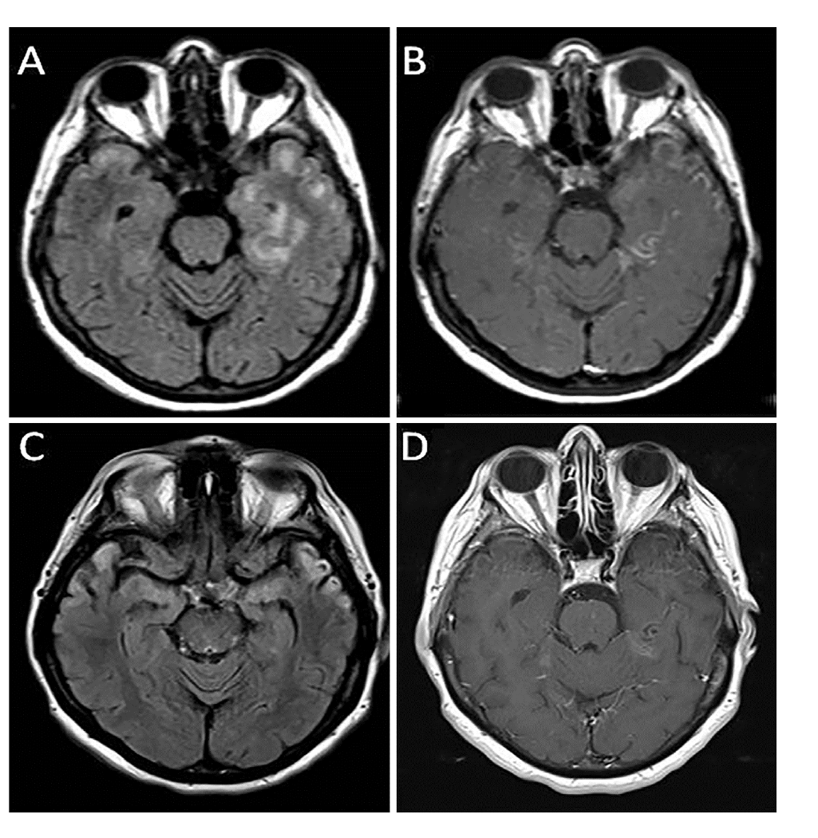Tablo 1. Olguların Klinik ve Paraklinik Özellikleri
Şekil 1. Olgu 2 kraniyal MRG. Aksiyel FLAIR ve kontrastlı kesitlerde sol temporal lobda belirgin, sağ temporal anterior kesimde daha sınırlı sinyal artışı ve meningeal tarzda kontrastlanma izlenmektedir.
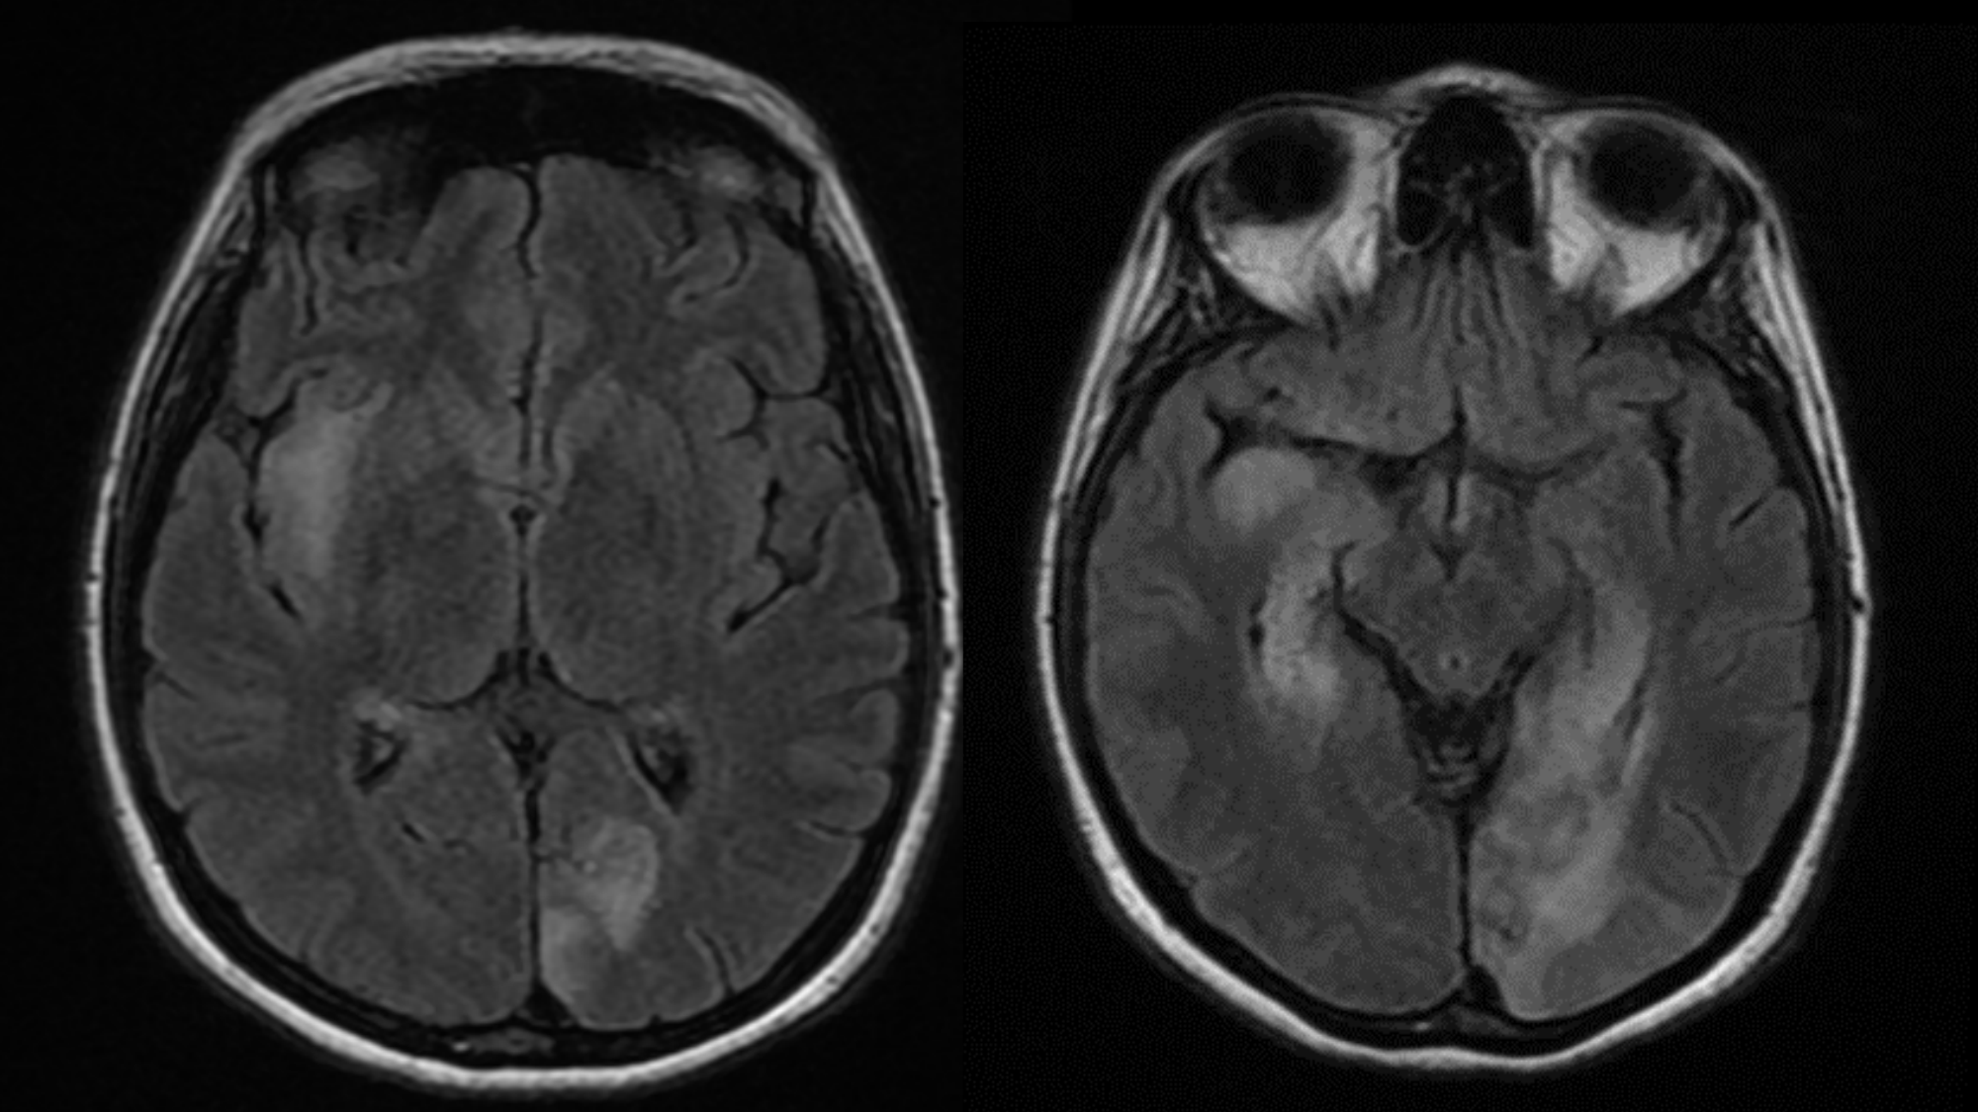
Şekil 2. Olgu 3 kraniyal MRG. Limbik/bazal ganglion bölgelerinde sinyal değişiklikleri bulunan kesitler. Klinik olarak hiponatremi ve fasiyobrakiyal distonik nöbet birlikteliği LGI1 ensefaliti fenotipini desteklemiştir.
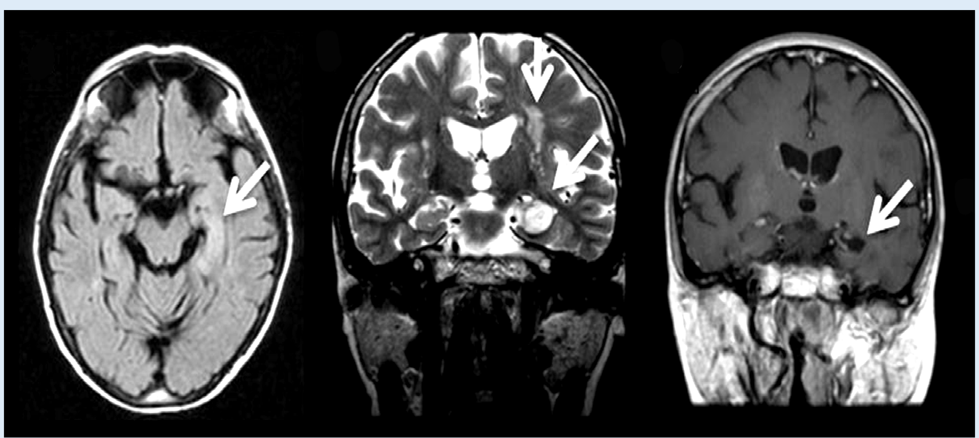
Şekil 3. Olgu 4 kontrol kraniyal MRG. Sol parahipokampal/mesial temporal bölgede patolojik sinyal ve kontrastlanma ile ilişkili kesitler.

SS-003 — Impact of Adverse Childhood Experiences on Lung Cancer Risk and the Role of Mediating Factors: A Case-Control Study
Çocukluk Çağı Travmaları ile Akciğer Kanseri ve Aracı Faktörler Arasındaki İlişki: Bir Klinik Vaka-Kontrol Çalışması
Yazarlar / Authors (onaylı sıra): Hülya Abalı
Sunumu yapan / Presenting author: Hülya Abalı
Çalışma türü / Manuscript type: Özgün araştırma, olgu-kontrol / Original case-control research
Bilim ve Yayın Kurullarının kabul ettiği tam metin. İçerik ve kaynakçalar gönderilen metinlere dayanır.
IMPACT OF ADVERSE CHILDHOOD EXPERIENCES ON LUNG CANCER RISK AND THE ROLE OF MEDIATING FACTORS: A CASE-CONTROL STUDY
Hülya Abalı¹
¹ Sağlık Bilimleri Üniversitesi, Yedikule Göğüs Hastalıkları ve Göğüs Cerrahisi Eğitim ve Araştırma Hastanesi, Göğüs Hastalıkları Anabilim Dalı, İstanbul, Türkiye
Sorumlu Yazar: Hülya Abalı · e-posta: hulayab@gmail.com
Çalışma Türü | Dil | Kelime | Sayfa
Özgün Araştırma | EN | 1967 | 10

ABSTRACT
Objective: Adverse childhood experiences (ACEs) are increasingly recognized as important life-course determinants of adult physical health, including cancer. This study aimed to investigate the association between ACEs and lung cancer using the Childhood Trauma Scale-33 (CTS-33) and its subscales, and to examine potential intermediary factors.
Methods: This observational case–control study included 60 patients with lung cancer and 60 healthy controls recruited from pulmonology outpatient clinics at a tertiary hospital. Childhood trauma exposure was assessed using the Turkish version of the CTS-33. Demographic, smoking, and histological cancer type data were collected via a face-to-face questionnaire. Group comparisons were performed using the Chi-square and Mann–Whitney U tests.
Results: Patients with lung cancer had significantly higher total CTS-33 scores compared with healthy controls (p = 0.01). Emotional abuse, physical abuse, physical neglect, and emotional neglect scores were also significantly higher in the patient group (p = 0.01, p = 0.01, p = 0.01, p = 0.00, respectively). Ever-smoker patients exhibited higher childhood trauma, emotional abuse, physical neglect, and emotional neglect scores than ever-smoker healthy individuals (p < 0.0001, p = 0.01, p < 0.0001, p < 0.0001, respectively). Smoking prevalence, smoking duration, and lower educational attainment were significantly more common among patients with lung cancer (p = 0.00 for all).
Conclusion: ACEs, particularly emotional and physical abuse and neglect, are significantly associated with lung cancer risk. Integrating trauma-informed care, educational interventions, and targeted tobacco-prevention strategies into cancer control programs offers a novel pathway to reduce the population burden of lung cancer.
Keywords: Childhood trauma, emotional abuse, lung cancer, CTS-33, smoking

INTRODUCTION
Adverse childhood experiences (ACEs) are traumatic and distressing events that occur before the age of 18 (1). Exposure to toxic stress during early life disrupts the immune, endocrine, and nervous systems, thereby increasing the risk of mental and physical health issues, substance use disorders, and adverse socioeconomic outcomes over the lifespan (2-4). Accumulating evidence indicates that a wide range of physical health conditions, including cancer, chronic obstructive pulmonary disease, asthma, coronary artery disease, stroke, diabetes, dyslipidemia, arthritis, liver, digestive, and kidney diseases, are associated with ACEs (5,6).
The first study demonstrating the link between ACEs and cancer was performed in animal models, revealing that early-life stressors increased susceptibility to tumor development (7). In humans, alterations in stress response and regulatory systems, chronic inflammation, immune dysregulation, and epigenetic modifications induced by early adverse experiences have been implicated in ACE-related carcinogenesis (8).
Lung cancer remains the leading cause of cancer-related morbidity and mortality worldwide (9). While tobacco consumption is the principal risk factor, genetic susceptibility, poor diet, occupational exposures, and air pollution contribute significantly to lung cancer risk (10). Given the rising global incidence of lung cancer, identifying modifiable and preventable risk factors is of paramount importance (11). ACEs represent one such potentially preventable factor. A large population-based study demonstrated a graded association between cumulative ACE exposure and lung cancer risk (12).
The primary aim of this study was to investigate the association between childhood trauma and its subtypes—emotional abuse, physical abuse, physical neglect, emotional neglect, sexual abuse, overprotection-control, and denial—and the development of lung cancer in adults using the Turkish version of CTS-33.13 The secondary aim was to evaluate the factors that may contribute to the observed relationship between ACEs and lung cancer.

MATERIAL AND METHOD
This observational case–control study was conducted in the pulmonology outpatient clinics of Yedikule Pulmonology Center and included 60 patients with lung cancer and 60 healthy individuals. Comparative analyses were performed between patients with lung cancer and healthy controls. Within the patient group, CTS-33 total and subscale scores were analyzed according to age, gender, smoking status, duration of smoking, marital status, educational level, and histological type of cancer. In addition, CTS-33 total and subscale scores were compared between ever-smoker patients with lung cancer and ever-smoker healthy individuals.
Participant Recruitment
Among individuals admitted to outpatient clinics between 30.06.2023 and 30.10.2024, healthy individuals aged 25-85, with no chronic diseases (e.g., cancer, cardiovascular diseases, diabetes, chronic obstructive pulmonary disease, asthma, liver, kidney, or digestive diseases), who consented to answer the questionnaire, participated in the study. Among patients with lung cancer admitted to outpatient clinics between 30.06.2023 and 30.10.2024, those aged 25-85 years without chronic diseases, cognitively able to cooperate, and who consented to complete the questionnaire were included in the study (Figure 1).

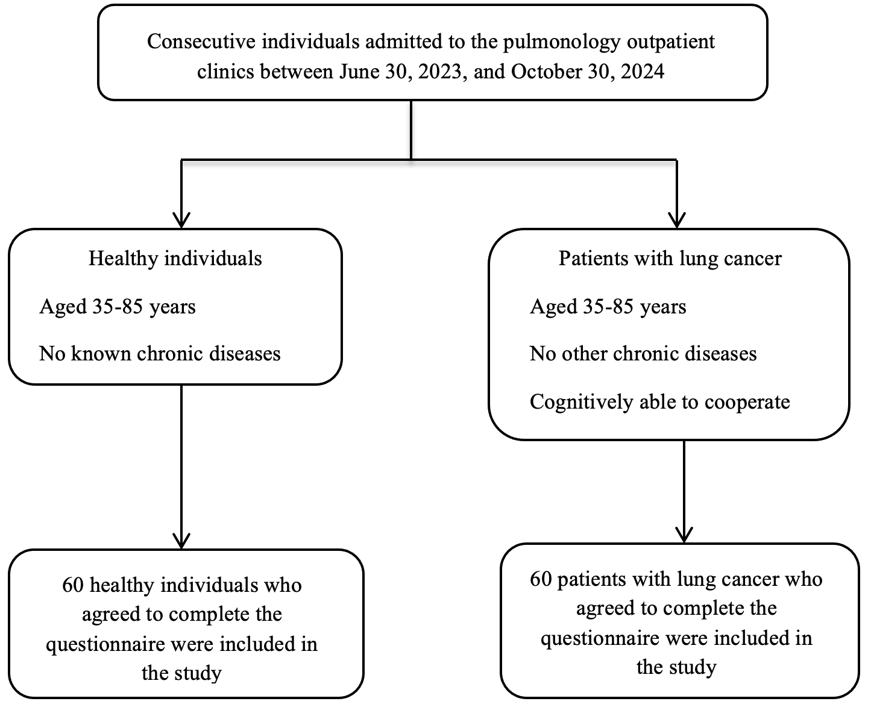

Figure 1. Flowchart of the study participants

Data Collection
Data on demographics; smoking status (current, non-, and former smokers); smoking duration (years); marital status (married, single, divorced, widow); educational attainment (illiterate, primary school, secondary/high school, university graduate); total CTS-33 scores; and scores for childhood trauma subscales (emotional abuse, physical abuse, physical neglect, emotional neglect, sexual abuse, overprotection/overcontrol, and denial) were collected via a questionnaire. The questionnaires were completed by the participants during face-to-face interviews.
Childhood Trauma Scale-33
CTS-33 is a retrospective assessment of individuals’ ACEs. The 33-item scale assessed ACEs in seven categories: physical abuse, emotional abuse, physical neglect, emotional neglect, sexual abuse, overprotection-overcontrol, and denial (minimizing). The Cronbach's alpha for the total CTS-33 score was 0.87, while the Gutman split-half coefficient was 0.69 (13).
The Cronbach's alpha values ​​obtained in this study were found to be 0.898 for the total CTS-33 score, 0.803 for emotional abuse, 0.822 for physical abuse, 0.722 for physical neglect, 0.833 for emotional neglect, 0.717 for sexual abuse, 0.785 for overprotection/control, and 0.633 for denial (minimizing).
Statistical Analysis
Statistical analyses were performed using IBM SPSS Statistics for Windows, version 25.0 (IBM Corp., Armonk, NY, USA). Categorical variables were summarized as frequencies and percentages and compared between groups using the Chi-square test of independence.
Because most CTS-33 total and subscale scores did not follow a normal distribution, comparisons between the lung cancer and healthy control groups were primarily conducted using the Mann–Whitney U test. Results were reported as mean ± standard deviation and mean rank values, where appropriate.
Within the patient group, the Mann–Whitney U test was used to compare total childhood trauma scores and the subscale scores of emotional abuse, physical abuse, physical neglect, sexual abuse, and denial (minimizing) according to age, gender, marital status, and educational level. An independent-samples t-test was used to compare emotional neglect and overprotection/overcontrol scores across the same variables. Comparisons of total childhood trauma scores and the subscale scores of emotional abuse, physical abuse, physical neglect, sexual abuse, and denial (minimizing) according to smoking status and duration of smoking were performed using the Kruskal–Wallis H test, while One-Way Analysis of Variance (ANOVA) was used to compare emotional neglect and overprotection/overcontrol scores.
All statistical tests were two-tailed, and a p-value of < 0.05 was considered statistically significant.

RESULTS
The average age of patients was 61.25 years, whereas that of healthy individuals was 52.55 years. The proportion of men was nonsignificantly higher in the patient group than in the healthy group (66.7% vs. 50%). Among histological types of lung cancer, adenocarcinoma was the most common (41.7%) (Table 1).
Chi-square test results revealed statistically significant differences between the groups regarding smoking status, smoking duration, and educational attainment (p = 0.001 for all). Ever-smokers were more prevalent among patients than among healthy individuals. Smoking duration was longer in the patient group compared to the healthy group. Additionally, the patient group had a lower educational attainment than the healthy group.
Table 1. Demographics, smoking and histological cancer type (author-supplied original table).
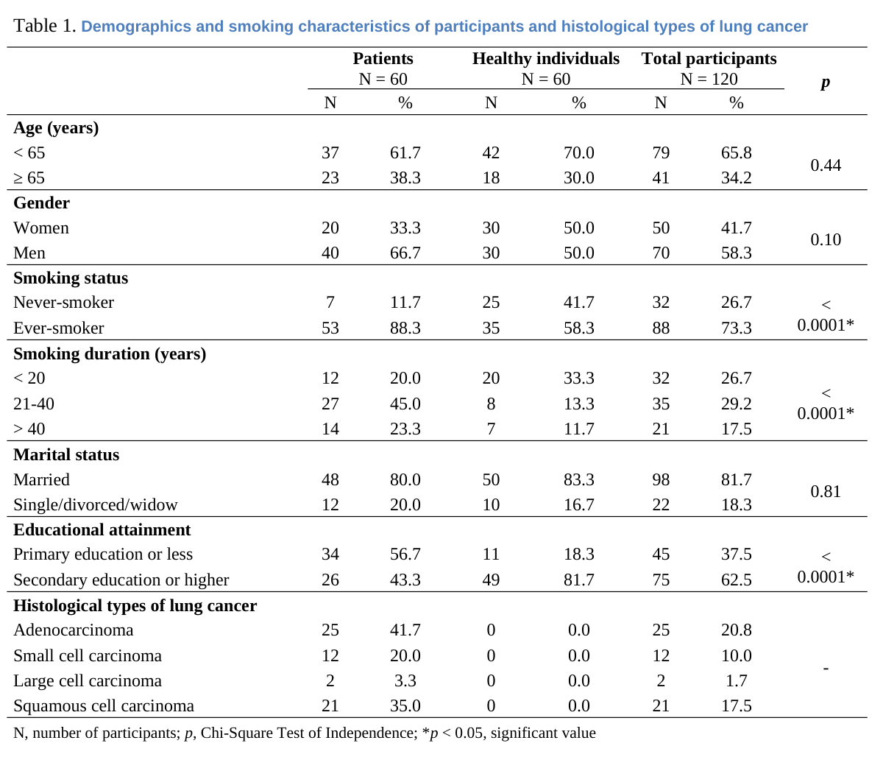
Compared with the healthy group, the patient group had significantly higher mean scores for overall childhood trauma, emotional abuse, physical abuse, physical neglect, and emotional neglect. The differences were statistically significant for all these variables (p = 0.01), except for emotional neglect, which was even more significant (p < 0.0001). However, the patient group did not show significant differences in sexual abuse, overprotection-overcontrol, or denial (minimizing) scores on the CTS-33 and its subscales (shown in Table 2, Figure 1).
Table 2. Childhood trauma scores by group (author-supplied original table).
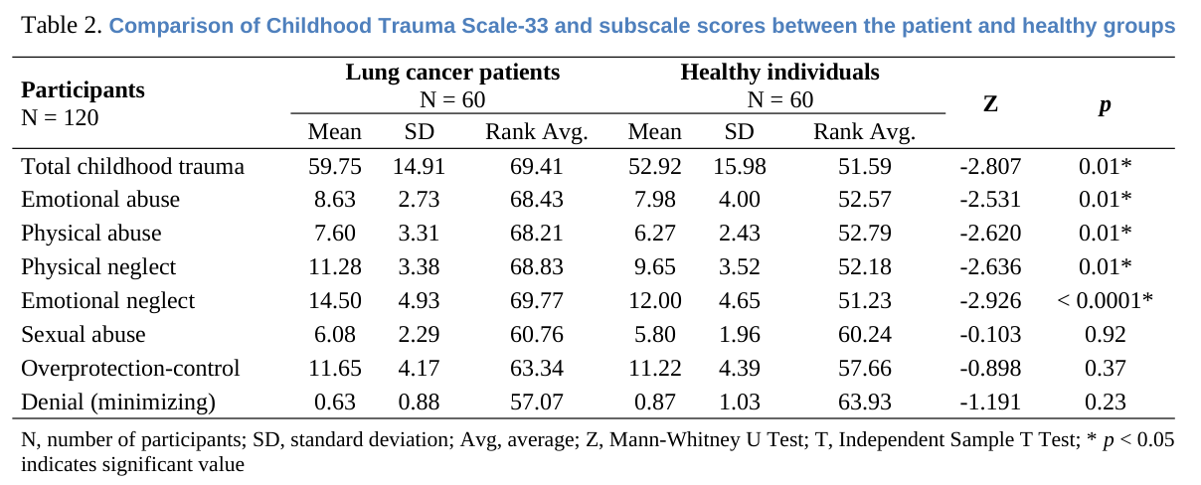
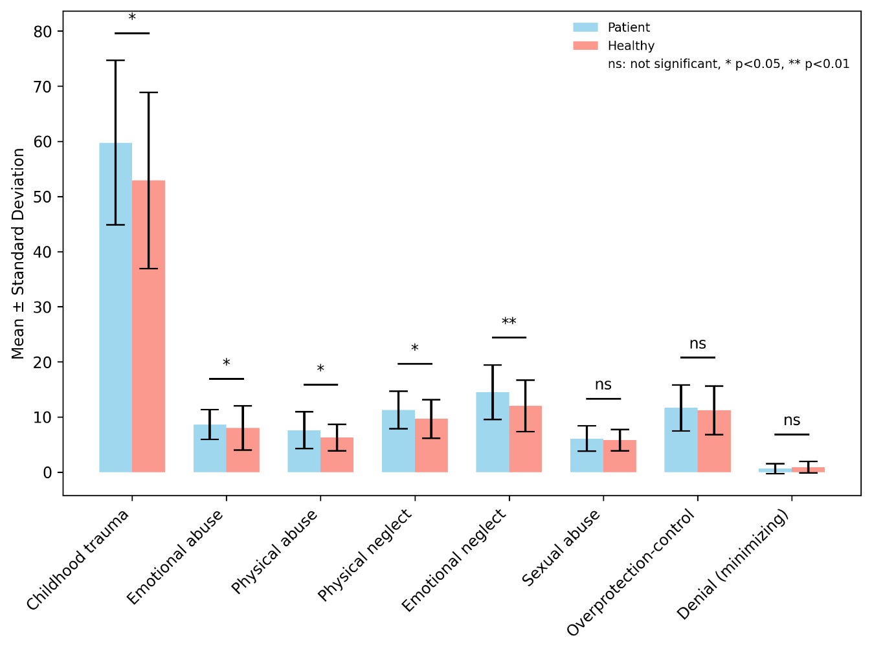
Figure 2. Comparison of Childhood Trauma Scale-33 and subscale scores between the patient and healthy groups

CTS-33 and subscale scores were compared between ever-smoker patients and ever-smoker healthy individuals. Ever-smoker patients had higher average scores for childhood trauma, emotional abuse, physical neglect, and emotional neglect compared to the ever-smoker healthy individuals (p = 0.00, p = 0.01, p = 0.00, and p = 0.00, respectively) (Table 3).

Table 3. Scores among ever-smoker participants (author-supplied original table).
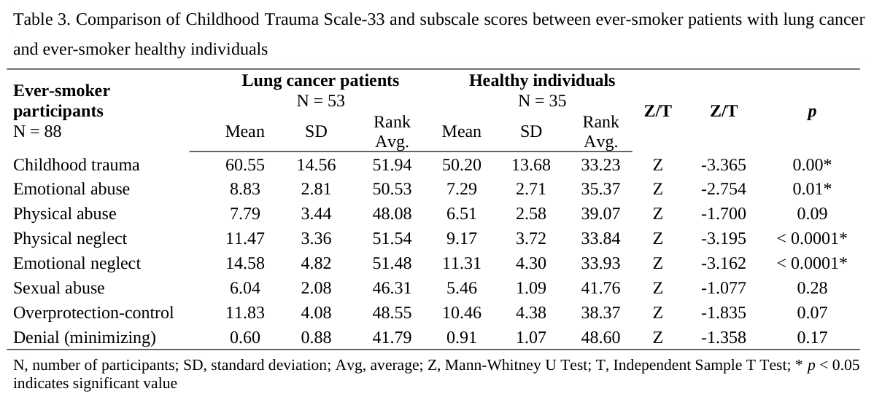
CTS-33 and its subscale scores of the patients were compared by age, gender, smoking status, smoking duration, marital status, educational attainment, and histological type of cancer. When comparing patient groups < 65 and ≥ 65 years old in terms of CTS-33 and its subscale scores, a significant difference was found only in the sexual abuse score. The mean sexual abuse score was higher in the patients < 65 years old than in those ≥ 65 years old (p = 0.04) (shown in Table 4, Figure 3). No significant differences in CTS-33 or subscale scores were observed across gender, smoking status, smoking duration, marital status, educational attainment, and histological type of cancer (p > 0.05).
Table 4. Scores in lung cancer patients by age (author-supplied original table).
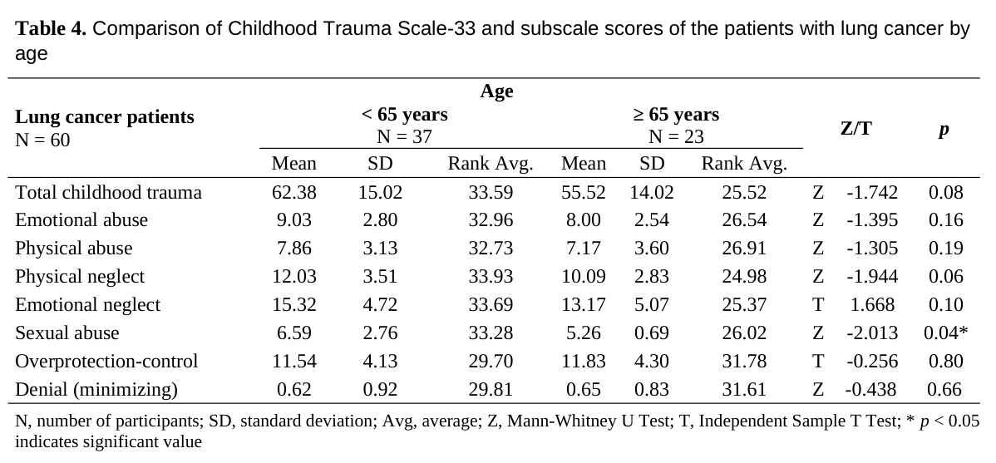
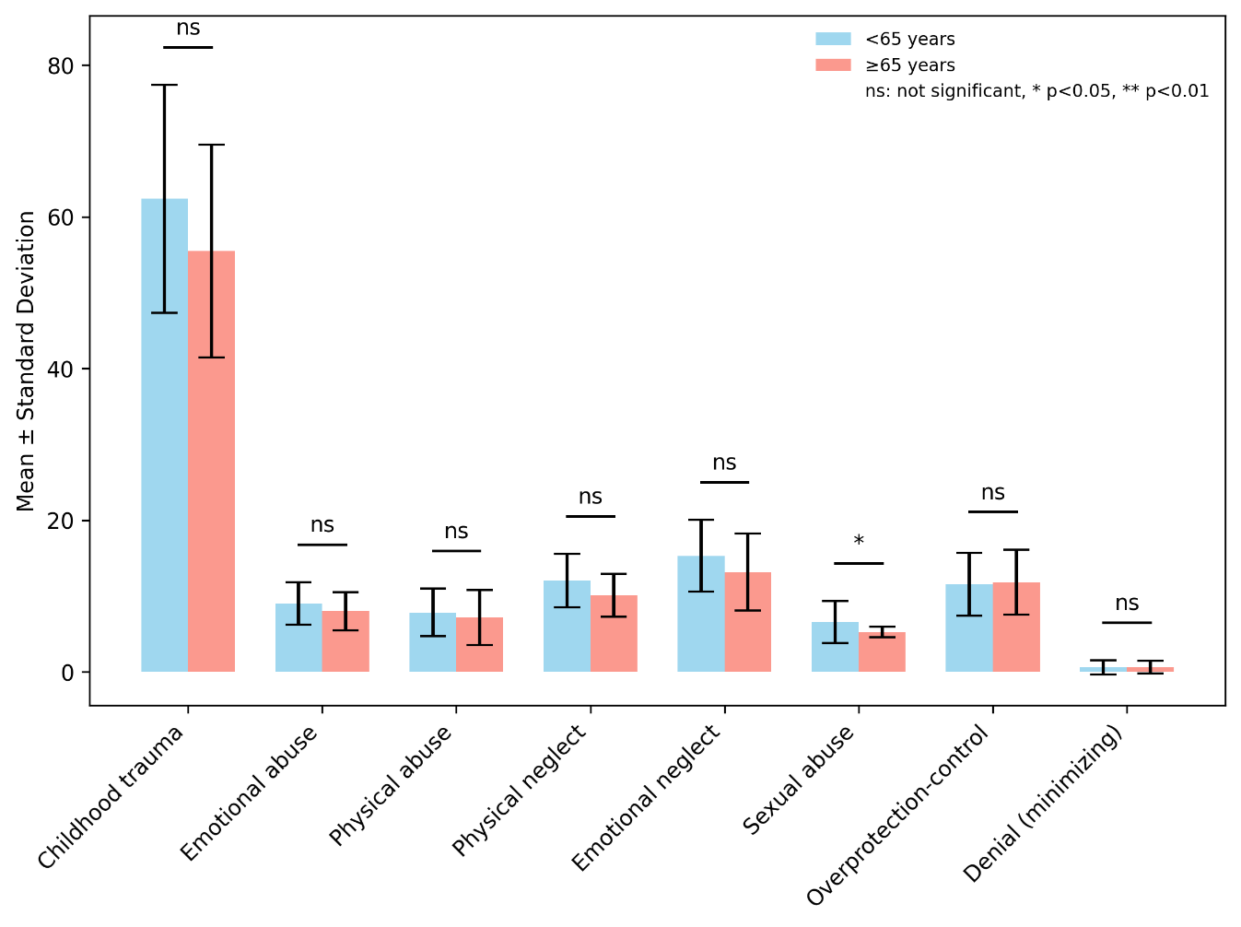
Figure 3. Comparison of the Childhood Trauma Scale-33 and subscale scores of patients with lung cancer by age
DISCUSSION
Numerous epidemiological studies have reported associations between ACEs and overall cancer incidence, as well as specific malignancies such as lung, cervical, and breast cancers (14). This case–control study expands on existing literature by evaluating the relationship between ACEs and lung cancer using the CTS-33 and its subscale scores, and by exploring potential mediating factors. Our primary findings indicate that patients with lung cancer reported significantly higher levels of total childhood trauma, emotional abuse, physical abuse, physical neglect, and emotional neglect compared with healthy controls. Consistent with our results, the only comparable study reported that individuals with six or more ACEs had an approximately threefold increased risk of lung cancer and developed the disease nearly 13 years earlier than those without ACEs (12). These findings support the hypothesis that early-life adversity contributes to lung carcinogenesis.
Individuals exposed to higher levels of childhood adversity are more likely to adopt health-risk behaviors, particularly smoking, which is the strongest established risk factor for lung cancer (15). In the present study, smoking prevalence and smoking duration were significantly higher among patients with lung cancer. Moreover, among ever-smokers, patients with lung cancer reported greater exposure to childhood trauma and its subscales, such as emotional abuse, physical neglect, and emotional neglect, than healthy individuals, suggesting that ACEs may influence both smoking initiation and prolonged tobacco exposure.
Beyond smoking behavior, ACEs may increase lung cancer risk through independent pathways, including reduced participation in cancer screening programs and biological mechanisms such as epigenetic alterations and chronic inflammation (16-18). Supporting this notion, Brown et al. demonstrated that the association between childhood adversity and lung cancer persisted even after adjustment for individual and parental smoking behaviors (12). Similarly, in our study, comparisons restricted to ever-smokers revealed a higher ACE burden among patients with lung cancer, indicating an effect beyond smoking alone.
Higher ACE scores are also associated with poorer academic achievement and lower educational attainment (19,20). Consistent with prior research, patients had higher ACE scores and lower educational levels than healthy individuals. Educational attainment, a core component of socioeconomic status, strongly influences health behaviors, access to healthcare, and occupational exposures (21). Lower educational attainment may indirectly increase lung cancer risk by limiting access to preventive services and smoking cessation resources while increasing smoking prevalence and exposure to environmental and occupational carcinogens (22,23). We hypothesize that reduced educational attainment among patients contributed to higher smoking rates and longer smoking duration, thereby facilitating lung cancer development.
When CTS-33 total and subscale scores were examined across demographic and clinical variables, age was the only factor associated with significant differences. Exposure to sexual abuse was reported more frequently by patients under 65 years of age. This finding may reflect a cohort effect, whereby younger generations have grown up in different social environments and demonstrate greater awareness and willingness to disclose childhood sexual trauma, rather than indicating a true difference in exposure. In contrast, older individuals may be less likely to report such experiences due to stronger social stigma, limited awareness, or recall bias.
The study has several limitations. The major limitation is its case–control design, which precludes causal inference. Although significant associations were observed between ACEs, smoking behavior, educational attainment, and lung cancer, the temporal and causal directions of these relationships could not be definitively established. Prospective longitudinal studies are required to confirm the proposed pathways linking ACEs to lung cancer risk. The sample size was relatively small, and the study was conducted at a single tertiary care center, which may limit the generalizability of the findings. Childhood trauma was evaluated retrospectively using a self-administered questionnaire. This method might be prone to recall bias, especially among individuals diagnosed with cancer, who might be more likely to remember or disclose adverse experiences. However, the CTS-33 has demonstrated strong reliability and validity, and internal consistency was high across most subscales in the present study, supporting the robustness of the measurements.
CONCLUSION
This case–control study demonstrates that ACEs, particularly emotional abuse, physical abuse, physical neglect, and emotional neglect, are significantly more prevalent among patients with lung cancer than among healthy controls. These associations persist even after accounting for smoking behavior, suggesting that ACEs may contribute to lung cancer risk both indirectly through increased smoking exposure and directly via psychosocial and biological pathways.
Our findings highlight the potential role of early-life adversity as an upstream determinant of lung cancer risk, mediated by higher smoking prevalence, longer smoking duration, and lower educational attainment. Recognizing ACEs as a modifiable and preventable risk factor may provide new opportunities for cancer prevention through early psychosocial interventions, improved educational support, and targeted smoking prevention strategies in vulnerable populations.
Future large-scale, prospective studies are needed to clarify causal pathways and to determine whether early identification and mitigation of childhood adversity can reduce lung cancer incidence and improve long-term cancer outcomes.
ETHICS AND RESEARCH DECLARATIONS
Ethics Committee Approval: This study was approved by the hospital's local Ethics Committee under reference number 147 (date: 02.06.2023). It was conducted in the pulmonology outpatient clinics of the study hospital in accordance with the Declaration of Helsinki.
Consent to Participate: All participants provided written informed consent.
Conflicts of Interest: The authors declared no conflicts of interest with respect to the research, authorship, and/or publication of this article.
Funding: The authors received no financial support for the research, authorship, or publication of this article.

References
- Merrill EC, Thomas AJ. Adverse childhood experiences and risk of late-life dementia: a systematic review and meta-analysis. Psychol Med. 2020;50(8):1314–1325.
- Pechtel P, Pizzagalli DA. Effects of early life stress on cognitive and affective function: an integrated review of human literature. Psychopharmacol (Berl). 2011;214(1):55–70.
- Danese A, McEwen BS. Adverse childhood experiences, allostasis, allostatic load, and age-related disease. Physiol Behav. 2012;106(1):29–39.
- Garner AS, Shonkoff JP, on behalf of the Committee on Psychosocial Aspects of Child and Family Health; Committee on Early Childhood, Adoption, and Dependent Care; Section on Developmental and Behavioral Pediatrics. Early childhood adversity, toxic stressMcG and the role of the pediatrician: translating developmental science into lifelong health. Pediatrics. 2012;129(1):e224–e231.
- Lin L, Wang Y, Chen X et al. Adverse Childhood Experiences and Subsequent Chronic Diseases Among Middle-aged or Older Adults in China and Associations With Demographic and Socioeconomic Characteristics. JAMA Netw Open. 2021;4(10):e2130950.
- Jemiyo C, McGregor BA, Rehana H, et al. Adverse childhood experiences and chronic health outcomes: evidence from 33 US states in the Behavioral Risk Factor Surveillance System, 2019-2023. BMC Public Health. 2025;25:1650.
- Lanconi E, Giannerini F, Colasanti A, et al. Early exposure to restraint stress enhances chemical carcinogenesis in rat liver. Cancer Lett. 2000;157(2):187–193.
- Taylor SE. Mechanisms linking early life stress to adult health outcomes. Proc Natl Acad Sci U S A. 2010;107(19):8507–8512.
- Zhou J, Xu Y, Liu J et al. (2024) Global burden of lung cancer in 2022 and projections to 2050: incidence and mortality estimates from GLOBOCAN. Cancer Epidemiology 93:102693.
- Malhotra J, Malvezzi M, Negri E, et al. Risk factors for lung cancer worldwide. Eur Respir J. 2016;47(1):125–137.
- Jakobsen E, Høgdall C, Aldrin M, et al. Forecasting lung cancer incidence, mortality, and prevalence to year 2030. BMC Cancer. 2021;21:985.
- Brown DW, Anda RF, Felitti VJ, et al. Adverse childhood experiences are associated with the risk of lung cancer: a prospective cohort study. BMC Public Health. 2010;10:20.
- Şar V, Necef I, Mutluer T, et al. A revised and expanded version of the Turkish Childhood Trauma Questionnaire (CTQ-33): overprotection-overcontrol as additional factor. J Trauma Dissociation. 2021;22(1):35-51.
- Holman DM, Ports KA, Buchanan ND, et al. The association between adverse childhood experiences and risk of cancer in adulthood: A systematic review of the literature. Pediatrics. 2016;138(Suppl 1):S81–S91.
- Felitti VJ, Anda RF, Nordenberg D, et al. Reprint of: Relationship of childhood abuse and household dysfunction to many of the leading causes of death in adults: The Adverse Childhood Experiences (ACE) Study. Am J Prev Med. 2019;56(6):774–786.
- Mouton CP, Hargreaves MK, Liu J, et al. Adult cancer risk behaviors associated with adverse childhood experiences in a low income population in the Southeastern United States. J Health Care Poor Underserved. 2016;27(1):68–83.
- Argentieri MA, Nagarajan S, Seddighzadeh B, et al. Epigenetic pathways in human disease: The impact of DNA methylation on stress-related pathogenesis and current challenges in biomarker development. EBioMedicine. 2017;18:327–350.
- Baumeister D, Akhtar R, Ciufolini S, et al. Childhood trauma and adulthood inflammation: a meta-analysis of peripheral C-reactive protein, interleukin-6 and tumour necrosis factor-α. Mol Psychiatry. 2015;21(5):642–649.
- Li M, D’Arcy C, Meng X. Association between adverse childhood experiences and academic performance among children and adolescents: A global meta-analysis. Child Abuse Negl. 2020;103:104493.
- Fisher C, Stillerman A, Feinglass J. The association of adverse childhood experiences with household income, educational attainment and partnered status among adults aged 30–39. Child Protection and Practice. 2024;5:Article 100097.
- Marmot M. Social determinants of health inequalities. Lancet. 2005;365(9464):1099–1104.
- Hodge JM, Patel AV, Islami F, et al. Educational Attainment and Cancer Incidence in a Large Nationwide Prospective Cohort. Cancer Epidemiol Biomarkers Prev. 2023;32(12):1747–1755.
- Borg M, Løkke A, Henriksen M, et al. Educational attainment and employment status in lung cancer patients: a nationwide study. Clin Transl Oncol. 2026;28(1):176–183.

AUTHOR’S STATEMENT
I declare that this is the final version of the complete text, that its content and ethical/consent/conflict-of-interest/funding statements are accurate, and that there is no identifiable patient data in the text.
Corresponding author: Hülya Abalı Date: 20.08.2026

SS-004 — Upper Airway Edema Following Intranasal Ecballium elaterium: An Emergency Department Case
İntranazal Ecballium elaterium Kullanımı Sonrasında Üst Havayolu Ödemi: Acil Servis Olgusu
Yazarlar / Authors (onaylı sıra): Talha Gökber Durmuş, Hasan Büyükaslan
Sunumu yapan / Presenting author: Talha Gökber Durmuş
Çalışma türü / Manuscript type: Olgu sunumu / Case report
Bilim ve Yayın Kurullarının kabul ettiği tam metin. İçerik ve kaynakçalar gönderilen metinlere dayanır.
Upper Airway Edema Following Intranasal Ecballium elaterium: An Emergency Department Case
Talha Gökber Durmuş¹, Hasan Büyükaslan¹
¹ Department of Emergency Medicine, Harran University Faculty of Medicine, Şanlıurfa, Türkiye
Abstract
Introduction
Ecballium elaterium, commonly known as squirting cucumber, grows widely in the Mediterranean region and has long been used as a traditional remedy. However, intranasal use of its fruit juice can cause marked irritation and swelling of the nasal and upper airway mucosa. Here, we describe a patient who developed uvular and oropharyngeal edema after intranasal exposure to E. elaterium.
Case Presentation
A 22-year-old patient with no known medical history presented to the emergency department with shortness of breath and a burning sensation in the nose after applying E. elaterium drops into both nostrils to induce sneezing. On arrival, the patient was hemodynamically stable. Blood pressure was 117/76 mmHg, heart rate was 75 beats/min, and oxygen saturation was 97%. Examination of the oropharynx revealed marked hyperemia and edema. Treatment with nebulized epinephrine, intravenous pheniramine, corticosteroid, and isotonic saline was initiated.
The patient was evaluated by the otolaryngology team because of concern about upper airway involvement. Examination showed uvular edema, hypertrophic nasal turbinates, and allergic secretions. Despite the edema, the airway was patent and the vocal cords were normal and mobile. Anesthesiology was also consulted for airway evaluation. During follow-up, the patient remained hemodynamically stable, with an oxygen saturation of 99%. Swallowing improved after treatment, although some difficulty persisted.
Discussion
Upper airway reactions following intranasal exposure to E. elaterium have been reported previously. The exact mechanism remains uncertain, and both an allergic response and direct irritation of the mucosa have been suggested. Most reported patients recover with medical treatment; however, swelling of the uvula and oropharynx can potentially progress and threaten the airway. For this reason, the initial appearance of clinical stability should not lead to underestimation of airway involvement. Careful examination and repeated assessment are particularly important when dyspnea or dysphagia is present.
Conclusion
Intranasal exposure to E. elaterium can result in significant uvular and oropharyngeal edema. Importantly, normal vital signs and preserved oxygen saturation do not exclude potentially important upper airway involvement. A history of herbal or traditional remedy use should therefore be considered in patients presenting to the emergency department with otherwise unexplained acute upper airway symptoms.
Keywords: Ecballium elaterium; squirting cucumber; uvular edema; oropharyngeal edema; herbal toxicity
Tam metin
Upper Airway Edema Following Intranasal Ecballium elaterium: An Emergency Department Case
1. Introduction
Ecballium elaterium (L.) A. Rich., commonly known as squirting cucumber, is a member of the Cucurbitaceae family and grows widely in the Mediterranean region. Its fruit juice has been used in traditional medicine for various inflammatory conditions, particularly sinonasal complaints, and this practice is also encountered in Türkiye [1,2].
Cucurbitacins are considered the main biologically active constituents of E. elaterium. Cucurbitacin B has shown anti-inflammatory activity in experimental studies [3–5], whereas other cucurbitacins isolated from the plant have demonstrated cytotoxic effects [1,6]. Intranasal use, especially when the juice is undiluted, has been associated with local irritation and edema involving the nasal and oropharyngeal mucosa. Uvular edema, dysphagia, dyspnea, and nasal swelling have all been reported [7,8].
The mechanism underlying these reactions remains unclear. Findings suggesting hypersensitivity have been reported in some patients, while severe mucosal irritation and even nasal necrosis in others indicate that direct local toxicity may also be involved [8,9]. We present a patient who developed uvular and oropharyngeal edema after intranasal use of E. elaterium, with particular attention to airway assessment and clinical observation in the emergency department.
2. Case Presentation
A 22-year-old patient with no known medical history presented to the emergency department with shortness of breath and a burning sensation in the nose after applying Ecballium elaterium drops into both nostrils to induce sneezing.
At presentation, the patient was hemodynamically stable, with a blood pressure of 117/76 mmHg, heart rate of 75 beats/min, and peripheral oxygen saturation of 97%. Examination showed marked hyperemia and edema of the oropharynx. Nebulized epinephrine, intravenous pheniramine, corticosteroid therapy, and intravenous isotonic saline were administered.
Given the possibility of upper airway involvement, an otolaryngology consultation was obtained. Examination revealed uvular edema, hypertrophic nasal turbinates, and allergic secretions. The airway remained patent, and the vocal cords were normal and mobile. Anesthesiology was also consulted to assess the airway.
During follow-up, the patient remained hemodynamically stable, and oxygen saturation increased to 99%. Swallowing improved after treatment, although some difficulty persisted.
3. Discussion
Upper airway reactions after intranasal use of Ecballium elaterium have been described in several reports, with presentations ranging from local nasal irritation to marked uvular and oropharyngeal edema [7,8]. Our patient developed nasal burning and dyspnea shortly after exposure, and examination revealed oropharyngeal hyperemia, uvular edema, and difficulty swallowing.
Cucurbitacins are thought to account for many of the biological effects of E. elaterium. Although anti-inflammatory properties have been demonstrated for some of these compounds [3–5], cytotoxic effects have also been reported [1,6,10]. This may partly explain the mucosal injury seen after intranasal exposure. The concentration and amount of the preparation are also likely to influence the severity of the reaction.
The exact mechanism of upper airway edema remains uncertain. Raikhlin-Eisenkraft and Bentur described pharyngeal edema, dyspnea, drooling, and dysphagia after E. elaterium exposure and suggested that undiluted juice may have a direct irritant effect on the mucosa [7]. Kloutsos et al., in a series of 42 patients, reported uvular and nasal mucosal edema as common findings. Positive allergy tests in some patients suggested that hypersensitivity may also play a role [8]. In contrast, the severe uvular edema and nasal mucosal necrosis reported by Eken et al. are more suggestive of direct tissue injury [9]. In our patient, the allergic secretions and uvular edema could indicate hypersensitivity, while nasal burning and mucosal hyperemia also favor a local irritant effect. Both mechanisms may have contributed.
The severity of airway involvement varies considerably. Life-threatening uvular angioedema has been reported following intranasal exposure to undiluted E. elaterium [11], while other cases have involved severe nasal obstruction and uvular edema [12,13]. Although our patient's airway remained patent and the vocal cords were normal and mobile, clear uvular and oropharyngeal edema was present. The initial oxygen saturation was 97%. This is clinically important because normal vital signs and preserved oxygen saturation do not exclude clinically significant upper airway involvement. Oxygen saturation may remain normal while substantial anatomical edema is already present. Persistent difficulty swallowing should also be taken seriously, as airway edema may progress over time.
In this case, otolaryngologic examination was useful in assessing the extent of edema and confirming airway patency and normal vocal cord mobility. Anesthesiology was also consulted because further progression might have required airway intervention. However, advanced airway management is not routinely necessary. None of the 42 patients reported by Kloutsos et al. required intubation or tracheotomy [8]. The decision to secure the airway should therefore depend on the clinical course and repeated airway findings.
Our patient was treated with nebulized epinephrine, intravenous pheniramine, corticosteroid therapy, and isotonic saline. Corticosteroids and antihistamines have also been used in previous reports [7,8,12]. Since the available evidence is largely limited to case reports and retrospective series, there is no established treatment protocol specific to E. elaterium toxicity. Careful observation and repeated airway assessment remain important regardless of the medical treatment given.
Several severe reactions have occurred after exposure to undiluted preparations [7,9,11], although the concentration and amount used by our patient were not known. Most previously reported patients used E. elaterium for sinusitis or related sinonasal complaints [3,5,8,11], whereas our patient used it to induce sneezing. This difference is noteworthy and shows that adverse reactions are not limited to its traditional therapeutic use. Asking specifically about herbal remedies may be helpful when evaluating patients with otherwise unexplained acute upper airway symptoms.
The main limitations of this report are the lack of information on the amount and concentration of the preparation, the interval between exposure and symptom onset, medication doses, allergy history, duration of observation, laboratory findings, and final disposition. These missing data were not inferred.
4. Conclusion
Intranasal Ecballium elaterium exposure may cause clinically significant uvular and oropharyngeal edema through allergic and/or direct toxic-inflammatory mechanisms. In our patient, substantial upper airway edema was present despite hemodynamic stability and an initial oxygen saturation of 97%. Normal vital signs and preserved oxygen saturation do not exclude clinically significant upper airway involvement. Careful airway examination and serial reassessment are therefore important, with otolaryngology and anesthesiology consultation when clinically indicated. A history of intranasal herbal or traditional remedy use should also be sought in patients presenting with otherwise unexplained acute upper airway symptoms.
References
1 Anzano A, de Falco B, Grauso L, Lanzotti V. Squirting cucumber, Ecballium elaterium (L.) A. Ritch: an update of its chemical and pharmacological profile. Molecules. 2024;29(18):4377. doi:10.3390/molecules29184377. PMID:39339372.
2. Kültür S. Medicinal plants used in Kırklareli Province (Turkey). J Ethnopharmacol. 2007;111(2):341-364. doi:10.1016/j.jep.2006.11.035. PMID:17257791.
3 Yesilada E, Tanaka S, Sezik E, Tabata M. Isolation of an anti-inflammatory principle from the fruit juice of Ecballium elaterium. J Nat Prod. 1988;51(3):504-508. doi:10.1021/np50057a008. PMID:3404148.
4 Yesilada E, Ustün O, Sezik E, Takaishi Y, Ono Y, Honda G. Inhibitory effects of Turkish folk remedies on inflammatory cytokines: interleukin-1α, interleukin-1β and tumor necrosis factor α. J Ethnopharmacol. 1997;58(1):59-73. doi:10.1016/S0378-8741(97)00076-7. PMID:9324006.
5 Uslu C, Karasen RM, Sahin F, Taysi S, Akcay F. Effect of aqueous extracts of Ecballium elaterium Rich. in the rabbit model of rhinosinusitis. Int J Pediatr Otorhinolaryngol. 2006;70(3):515-518. doi:10.1016/j.ijporl.2005.07.020. PMID:16191438.
6 Jafargholizadeh N, Zargar SJ, Yassa N, Tavakoli S. Purification of cucurbitacins D, E, and I from Ecballium elaterium (L.) A. Rich fruits and study of their cytotoxic effects on the AGS cell line. Asian Pac J Cancer Prev. 2016;17(10):4631-4635. doi:10.22034/APJCP.2016.17.10.4631. PMID:27892675.
7 Raikhlin-Eisenkraft B, Bentur Y. Ecbalium elaterium (squirting cucumber)—remedy or poison? J Toxicol Clin Toxicol. 2000;38(3):305-308. doi:10.1081/CLT-100100936. PMID:10866331.
8 Kloutsos G, Balatsouras DG, Kaberos AC, Kandiloros D, Ferekidis E, Economou C. Upper airway edema resulting from use of Ecballium elaterium. Laryngoscope. 2001;111(9):1652-1655. doi:10.1097/00005537-200109000-00030. PMID:11568622.
9 Eken C, Ozbek K, Yildirim CK, Eray O. Severe uvular edema and nasal mucosal necrosis due to Ecbalium elaterium (squirting cucumber): an allergic reaction or direct toxic effect? Clin Toxicol (Phila). 2008;46(3):257-258. doi:10.1080/15563650601158834. PMID:18344108.
10 Jafargholizadeh N, Zargar SJ, Aftabi Y. The cucurbitacins D, E, and I from Ecballium elaterium (L.) upregulate the LC3 gene and induce cell-cycle arrest in human gastric cancer cell line AGS. Iran J Basic Med Sci. 2018;21(3):253-259. doi:10.22038/IJBMS.2018.25175.6236. PMID:29511491.
11 Satar S, Gokel Y, Toprak N, Sebe A. Life-threatening uvular angioedema caused by Ecbalium elaterium. Eur J Emerg Med. 2001;8(4):337-339. doi:10.1097/00063110-200112000-00018.
12 Caiozzi G, Cabrera D, Mardónez JM, Saldías F. Herbal medicines and severe adverse effects: uvular angioedema caused by Echballium elaterium. Rev Med Chil. 2002;130(12):1407-1410. PMID:12611242.
13 Aydogan K, Yazici S, Turan H. A rare reason for uvular angioedema: Ecbalium elaterium. Ann Dermatol. 2012;24(3):358-359. doi:10.5021/ad.2012.24.3.358. PMID:22879724.

SS-005 — Esophageal Perforation Diagnosed Following Cardiopulmonary Arrest: A Case Report
Kardiyopulmoner Arrest Sonrasında Tanı Konulan Özofagus Perforasyonu: Olgu Sunumu
Yazarlar / Authors (onaylı sıra): Gülendam Alkan, Esat Barut
Sunumu yapan / Presenting author: Gülendam Alkan
Çalışma türü / Manuscript type: Olgu sunumu / Case report
Bilim ve Yayın Kurullarının kabul ettiği tam metin. İçerik ve kaynakçalar gönderilen metinlere dayanır.
Kardiyopulmoner Arrest Sonrasında Tanı Konulan Özofagus Perforasyonu: Olgu Sunumu
Gülendam Alkan¹, Esat Barut¹
¹Harran Üniversitesi, Acil Tıp Anabilim Dalı, Şanlıurfa, Türkiye
YAZAR BEYANI
Bu tam metnin son sürüm olduğunu, tüm yazarların içeriği ve yazar sırasını onayladığını, etik/onam/çıkar çatışması/finansman beyanlarının doğru olduğunu ve metinde tanımlanabilir hasta verisi bulunmadığını beyan ederim.
Sorumlu Yazar: Dr. Öğr. Üyesi Esat BARUT, esbarut94@gmail.com, ORCID ID: 0000-0003-0844-0468
Tarih: [20.08.2026]
ÖZET
Özofagus perforasyonu, acil serviste farklı klinik tabloları taklit edebilen, nadir ancak yüksek mortalite ile ilişkili gastrointestinal bir acildir. Bu olguda, şiddetli bulantı ve kusma ile birlikte dispne sonrası kardiyopulmoner arrest (KPA) gelişen ve spontan dolaşım sağlandıktan sonra yapılan görüntülemelerde özofagus perforasyonu saptanan bir hasta sunulmaktadır. Yetmiş dört yaşında kadın hasta sabah saat 04.00 civarında başlayan şiddetli nefes darlığı, soğuk terleme, bulantı ve kusma şikayetleriyle dış merkez acil servisine başvurduğunda oksijen satürasyonu %40, nabzı 20/dk olarak saptanmış ve kısa süre sonra KPA gelişmiş. Entübe edilerek 30 dakika kardiyopulmoner resüsitasyon uygulanan hasta, spontan dolaşım sağlandıktan sonra hastanemiz acil servisine sevk edildi. Kabulünde Glasgow Koma Skoru 3, kan basıncı 78/46 mmHg, nabız 82/dk ve mekanik ventilasyon altında SpO₂ %98 idi. Batın distandü, bilateral solunum sesleri azalmış ve bazallerde ralleri mevcuttu. Görüntülemelerinde bilateral pnömotoraks, plevral sıvı, pulmoner ödem, aspirasyon infiltrasyonları, pnömomediastinum, sternal ve çoklu kosta kırıkları ile distal özofagus düzeyinden batına uzanan yaygın serbest hava ve intrahepatik portal venöz gaz saptandı. Bulgular gastrointestinal perforasyonu düşündürdü. Genel cerrahi tarafından acil cerrahi uygulanan hastada perforasyon doğrulandı ve hasta yoğun bakım ünitesine yatırıldı. Şiddetli kusma ve dispne sonrası KPA gelişen hastalarda özofagus perforasyonu ayırıcı tanıda göz önünde bulundurulmalıdır. Yaygın serbest hava ve portal venöz gaz, gastrointestinal perforasyon açısından uyarıcı olmalıdır. Erken görüntüleme, tanı ve uygun cerrahi tedavinin gecikmeden planlanmasında kritik rol oynayabilir.
Anahtar Kelimeler: Kardiyopulmoner arrest, özofagus perforasyonu, portal venöz gaz, acil tıp.
ABSTRACT
Esophageal perforation is a rare but life-threatening gastrointestinal emergency that can mimic various clinical conditions in the emergency department. We present a patient who developed cardiopulmonary arrest (CPA) following dyspnea accompanied by severe nausea and vomiting, in whom esophageal perforation was identified on imaging performed after return of spontaneous circulation. A 74-year-old woman presented to an outside emergency department with severe dyspnea, cold sweating, nausea, and vomiting that had started at approximately 4:00 AM. Her oxygen saturation was 40% and her heart rate was 20 beats/min, followed shortly thereafter by CPA. She was intubated and underwent 30 minutes of cardiopulmonary resuscitation before being transferred to our emergency department after return of spontaneous circulation. On admission, her Glasgow Coma Scale score was 3, blood pressure was 78/46 mmHg, heart rate was 82 beats/min, and SpO₂ was 98% under mechanical ventilation. The abdomen was distended, bilateral breath sounds were decreased, and basal crackles were present. Imaging revealed bilateral pneumothorax, pleural effusion, pulmonary edema, aspiration-related infiltrates, pneumomediastinum, sternal and multiple rib fractures, extensive free air extending from the distal esophageal level into the abdomen, and intrahepatic portal venous gas. These findings raised suspicion for gastrointestinal perforation. Emergency surgery was performed by the general surgery team, confirming the perforation, and the patient was subsequently admitted to the intensive care unit. Esophageal perforation should be considered in the differential diagnosis of patients who develop CPA following severe vomiting and dyspnea. Extensive free air and portal venous gas should raise suspicion for gastrointestinal perforation. Early imaging may play a critical role in establishing the diagnosis and facilitating timely planning of appropriate surgical treatment.
Keywords: Cardiopulmonary arrest, esophageal perforation, portal venous gas, emergency medicine.
GİRİŞ
Özofagus perforasyonu, özofagus duvarının tüm katlarının bozulmasıyla çevre mediastinal, plevral veya abdominal alanların gastrointestinal içerikle kontaminasyonuna yol açan, nadir fakat yaşamı tehdit eden bir acil durumdur (1). Klinik bulgular özgül değildir; göğüs veya epigastrik ağrı, kusma, dispne, ateş, şok ve subkutan amfizem gibi farklı kombinasyonlarda ortaya çıkabilir. Klasik bulguların bulunmaması tanıyı dışlamadığından, özellikle eşlik eden komorbiditeleri olan hastalarda tanısal gecikmeler görülebilir (2, 3). Tedavideki gecikme ise olumsuz sonuçların ve mortalitenin en önemli belirleyicisidir (1, 2). Kontrastlı bilgisayarlı tomografi (BT) ve uygun hastalarda BT özofagografi, perforasyonu ve mediastinal/plevral yayılımı değerlendirmede temel görüntüleme yöntemlerindendir (1, 4).
Bu olguda, şiddetli bulantı ve kusma ile birlikte dispne sonrası kardiyopulmoner arrest (KPA) gelişen ve spontan dolaşım sağlandıktan sonra yapılan görüntülemelerde özofagus perforasyonu saptanan bir hasta sunulmaktadır.
OLGU SUNUMU
Yetmiş dört yaşında kadın hasta; hipertansiyon, diabetes mellitus, koroner arter hastalığı ve kronik lenfositik lösemi öyküsü ile değerlendirildi. Sabah saat 04.00 civarında başlayan şiddetli nefes darlığı, soğuk terleme, bulantı ve kusma yakınmaları nedeniyle dış merkez acil servisine başvuran hastanın ilk değerlendirmesinde oksijen satürasyonu %40 ve nabız 20/dk olarak saptanmış. Kısa süre içinde KPA gelişmesi üzerine hasta entübe edilmiş ve yaklaşık 30 dakika kardiyopulmoner resüsitasyon uygulanmış. Spontan dolaşım sağlandıktan sonra ise ileri değerlendirme ve tedavi amacıyla hastanemiz acil servisine sevk edildi.
Kabulünde hasta entübe ve mekanik ventilasyon altındaydı. Glasgow Koma Skoru 3, kan basıncı 78/46 mmHg, nabız 82/dk ve periferik oksijen satürasyonu %98 olarak ölçüldü. Fizik muayenede batın distandü, bilateral solunum sesleri azalmış ve bazallerde raller mevcuttu. Kan gazında pH 7,157, bikarbonat 17 mmol/L ve laktat 7,55 mmol/L saptanması ciddi metabolik asidoz ve doku hipoperfüzyonu ile uyumluydu. Glukoz 485 mg/dL, potasyum 5,61 mmol/L, troponin-I 204,22 pg/mL ve CK-MB 17,02 ng/mL idi. Kardiyak biyobelirteç yüksekliği, KPA ve resüsitasyon sonrasında gelişen miyokardiyal hasar ile uyumlu olarak değerlendirildi.
Kontrastlı toraks ve batın BT’sinde bilateral pnömotoraks, plevral sıvı, pulmoner ödem ve aspirasyon ile uyumlu infiltrasyonlar izlendi. Ayrıca pnömomediastinum, sternal ve çoklu kosta kırıkları, distal özofagus düzeyinden batına doğru uzanan yaygın serbest hava, intrahepatik portal venöz gaz ve dilate kolonik anslarda ileus lehine hava-sıvı seviyeleri saptandı.
Pnömotoraks, pnömomediastinum ve kosta/sternum kırıkları CPR’a bağlı travmatik komplikasyonlar olarak değerlendirildi. Bununla birlikte distal özofagus çevresindeki yaygın hava, intraperitoneal serbest hava ve portal venöz gazın birlikte bulunması, gastrointestinal sistem perforasyonu yönünden yüksek riskli bir tabloya işaret etti (Şekil 1).
Şekil 1. Özofagus perforasyonunu düşündüren kontrastlı bilgisayarlı tomografi bulguları. (A) Distal özofagusu çevreleyen ve periton boşluğuna uzanan ekstralüminal hava. (B) İntrahepatik portal venöz gaz ve buna eşlik eden serbest intraperitoneal hava.
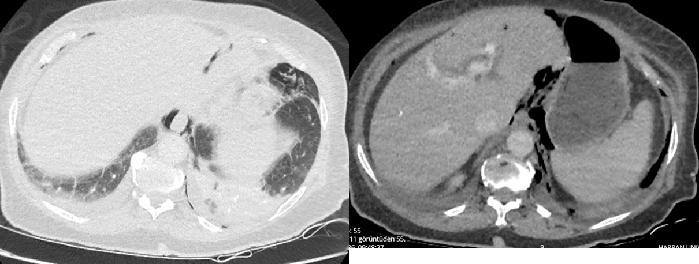
Klinik öykü ve BT bulguları birlikte değerlendirilerek özofagus perforasyonu ön tanısı ile genel cerrahi ve yoğun bakım ekipleri acil olarak bilgilendirildi. Genel cerrahi tarafından acil cerrahi tedavi uygulandı; operasyon sırasında gastrointestinal sistem perforasyonu doğrulandı ve hasta yoğun bakım ünitesine yatırıldı.
TARTIŞMA
Özofagus perforasyonunda klinik belirtiler erken dönemde özgül olmayabilir. Özellikle entübe, bilinçsiz veya resüsitasyon sonrası değerlendirilen hastalarda göğüs ağrısı, odinofaji ve subkutan amfizem gibi klasik ipuçları değerlendirilemez. Bu nedenle şiddetli kusma öyküsü ile birlikte ani dispne, hipoksemi, açıklanamayan şok veya metabolik asidoz varlığında özofagus perforasyonu akılda tutulmalıdır. Acil tıp literatüründe, klasik bulguların yokluğunun perforasyonu dışlamak için kullanılmaması ve ileri görüntülemenin tanı, hastalık şiddetinin belirlenmesi ve tedavinin yönlendirilmesi için gerekli olduğu vurgulanmaktadır (3). WSES kılavuzuna göre özofagus perforasyonunda tanı ve tedavi gecikmesi, sepsis ve ölüm riskini artıran temel faktördür (1).
Bu olguda KPA sonrası görülen pnömotoraks, pnömomediastinum ve çoklu kosta kırıkları öncelikle mekanik CPR komplikasyonları olarak yorumlanabilirdi. Ancak CPR komplikasyonlarının varlığı, resüsitasyon öncesinde başlayan şiddetli kusma ve dispnenin nedenini açıklamamaktadır. Bu nedenle post-resüsitasyon BT’de saptanan torasik bulgular, CPR komplikasyonu olarak kabul edilmeden önce arrest öncesi klinik tablo ile birlikte yorumlanmalıdır.
Özofagus perforasyonunda BT’nin tanısal değeri yüksek olup mediastinal hava veya sıvı, plevral efüzyon, pnömotoraks ve intraperitoneal hava gibi bulgular perforasyonun yayılımını göstermede yararlıdır (1, 2). Bu nedenle resüsitasyon sonrası çekilen BT yalnızca travmatik komplikasyonlar açısından değil, arrestin geri döndürülebilir nedenleri ve gastrointestinal perforasyon açısından da sistematik olarak incelenmelidir.
Portal venöz gaz, eskiden doğrudan cerrahi gerektiren ve ölüm habercisi kabul edilen bir bulgu olarak değerlendirilmiş olsa da günümüzde tek başına ameliyat endikasyonu değildir. Portal venöz gaz; bağırsak iskemi ve nekrozu, intestinal distansiyon, inflamasyon, enfeksiyon veya mukozal bütünlüğün bozulması gibi farklı süreçlerde görülebilir. Klinik durum, laktat düzeyi, peritonit bulguları ve eşlik eden BT bulguları ile birlikte yorumlanmalıdır (5, 6). Bununla birlikte bu olguda portal venöz gazın yaygın serbest hava, ileus bulguları, hemodinamik instabilite ve distal özofagus çevresindeki hava ile birlikte görülmesi, bulgunun altta yatan perforasyon ve kontaminasyonla ilişkili olabileceğini düşündürmüştür.
Tedavi; perforasyonun yeri, serbest veya sınırlı olması, mediastinal/plevral kontaminasyonun derecesi, başvuru süresi ve hastanın hemodinamik durumuna göre belirlenir. Stabil, erken başvuran, sınırlı ve çevre dokulara minimal kontaminasyonu olan seçilmiş hastalarda yakın izlem, oral alımın kesilmesi, geniş spektrumlu antibiyotik, asit baskılama, beslenme desteği ve endoskopik veya perkütan drenaj içeren nonoperatif yaklaşım düşünülebilir (1, 2, 3). Acil serviste başlangıç yönetimi hemodinamik stabilizasyon, gastrik dekompresyon, geniş spektrumlu antibiyotik ve uygun hava yolu yaklaşımını içermelidir (3). Buna karşın serbest perforasyon, yaygın plevral veya mediastinal kontaminasyon, sepsis ya da hemodinamik instabilite varlığında acil cerrahi değerlendirme gereklidir (1). Cerrahi tedavinin ilk 24 saat içinde başlatılması, daha geç tedaviye kıyasla daha düşük mortalite ile ilişkilendirilmiştir (7). Bu olguda şok, ciddi laktik asidoz, yaygın serbest hava ve portal venöz gazın birlikte olması, gecikmeksizin cerrahi yaklaşım gerektiren yüksek riskli bir tablo oluşturmuştur.
SONUÇ / ÖĞRENİM NOKTALARI
Şiddetli kusma ve ani dispne sonrasında KPA gelişen hastalarda primer kardiyak nedenlerin yanı sıra gastrointestinal perforasyonlar da ayırıcı tanıda değerlendirilmelidir. KPA sonrası pnömotoraks, pnömomediastinum ve kosta kırıkları CPR komplikasyonları olabilir; ancak bu bulgular arrest öncesi semptomları açıklamıyorsa, eşlik eden serbest hava ve portal venöz gaz gastrointestinal perforasyon açısından uyarıcı kabul edilmelidir. Kontrastlı toraks-abdomen BT’nin erken kullanımı, perforasyonun yerini ve yayılımını göstermede kritik rol oynar. Hemodinamik instabilite ve yaygın kontaminasyon bulguları bulunan hastalarda acil multidisipliner cerrahi değerlendirme geciktirilmemelidir.
AYDINLATILMIŞ ONAM
Bu olgu sunumunun hazırlanması, bilimsel toplantıda sunulması ve bilimsel olarak yayımlanması amacıyla hastanın yasal temsilcisinden yazılı aydınlatılmış onam alınmıştır. Hasta kimliğinin belirlenmesine olanak verebilecek tüm bilgiler anonimleştirilmiştir.
KAYNAKLAR
1.Chirica M, Kelly MD, Siboni S, et al. Esophageal emergencies: WSES guidelines. World Journal of Emergency Surgery. 2019;14:26. doi:10.1186/s13017-019-0245-2
2.Søreide JA, Viste A. Esophageal perforation: diagnostic work-up and clinical decision-making in the first 24 hours. Scandinavian Journal of Trauma, Resuscitation and Emergency Medicine. 2011;19:66. doi:10.1186/1757-7241-19-66
3.DeVivo A, et al. High risk and low prevalence diseases: Esophageal perforation. American Journal of Emergency Medicine. 2022;53:29–36. doi:10.1016/j.ajem.2021.12.017
4.Norton-Gregory AA, Kulkarni NM, O’Connor SD, et al. CT Esophagography for Evaluation of Esophageal Perforation. RadioGraphics. 2021;41(2):447–461. doi:10.1148/rg.2021200132
5.Abboud B, El Hachem J, Yazbeck T, Doumit C. Hepatic portal venous gas: physiopathology, etiology, prognosis and treatment. World Journal of Gastroenterology. 2009;15(29):3585–3590. doi:10.3748/wjg.15.3585
6.McElvanna K, Campbell A, Diamond T. Hepatic portal venous gas—three non-fatal cases and review of the literature. Ulster Medical Journal. 2012;81(2):74–78. PubMed Central
7.Biancari F, D’Andrea V, Paone R, et al. Current treatment and outcome of esophageal perforations in adults: systematic review and meta-analysis of 75 studies. World Journal of Surgery. 2013;37(5):1051–1059. doi:10.1007/s00268-013-1951-7

SS-006 — From Low Back Pain to Paraplegia
Bel Ağrısından Paraplejiye
Yazarlar / Authors (onaylı sıra): İlhami Yüksel, Hasan Büyükaslan
Sunumu yapan / Presenting author: İlhami Yüksel
Çalışma türü / Manuscript type: Olgu sunumu / Case report
Bilim ve Yayın Kurullarının kabul ettiği tam metin. İçerik ve kaynakçalar gönderilen metinlere dayanır.
From Low Back Pain to Paraplegia
İlhami Yüksel¹, Hasan Büyükaslan¹
¹ Department of Emergency Medicine, Harran University Faculty of Medicine, Şanlıurfa, Türkiye
Introduction
Acute bilateral lower limb weakness is a challenging presentation in the emergency department, as it may be associated with several conditions requiring urgent diagnosis and treatment, including spinal cord compression, cauda equina syndrome, spinal vascular disorders, inflammatory myelopathies, and acute polyradiculoneuropathies. We present a patient who was able to walk on arrival but developed rapidly progressive neurological deficits while being observed in the emergency department.
Case Presentation
A man in his forties presented to the emergency department early in the morning because of low back pain that had started the previous evening. He had a history of intermittent low back pain and lumbar disc herniation but no other known medical condition or regular medication use. On arrival, he was alert, cooperative, and oriented, and his vital signs were stable.
The patient was initially able to walk in the emergency department. During follow-up, however, weakness developed first in his left leg and then progressed to involve the right leg. Neurological examination showed normal strength in both upper extremities (5/5), whereas muscle strength was 0/5 in both lower extremities. Patellar and Achilles reflexes were absent. Bilateral lower extremity hypoesthesia was also present and was more prominent on the left. The patient reported that he could still feel the urge to urinate and defecate. He had no history of an upper respiratory tract infection or diarrhea during the preceding 10 days.
Diffusion-weighted brain MRI performed at another center showed no evidence of an acute neurological lesion. Non-contrast lumbar MRI revealed a suspicious area of increased T2 signal at the L3 level. Neurosurgery was consulted, but emergency surgery was not considered necessary. The patient was subsequently evaluated by the neurology team and admitted to the neurology ward for further investigation.
Discussion
Rapidly progressive paraplegia has a broad differential diagnosis. Spinal compression, cauda equina syndrome, spinal cord ischemia, inflammatory myelopathies, and Guillain–Barré syndrome should all be considered, particularly when neurological deficits evolve over a short period. In such patients, the pattern and progression of weakness, neurological localization, and repeated neurological examinations can provide important clues to the underlying diagnosis.
Conclusion
A patient who is able to walk on arrival may still develop a severe neurological deficit within hours. When neurological symptoms are progressive, a single examination may not reflect the subsequent clinical course. Repeated neurological assessment and timely investigation of potentially serious spinal and peripheral neurological causes are therefore essential in the emergency department.
From Low Back Pain to Paraplegia
Tam Metin
Introduction
Acute or rapidly progressive weakness of both lower extremities is an important neurological presentation in the emergency department (ED), particularly because several potentially serious conditions may present in a similar manner. Depending on the anatomical level involved, the underlying pathology may arise from the spinal cord, conus medullaris, cauda equina, nerve roots, peripheral nerves, neuromuscular junction, or, less commonly, muscle. Among the major conditions that need to be considered are spinal cord compression, cauda equina syndrome (CES), spinal cord ischemia or infarction, inflammatory myelopathies, and acute polyradiculoneuropathies such as Guillain–Barré syndrome (GBS) [1–4]. Distinguishing among these disorders is clinically important because both the urgency of intervention and the diagnostic approach may differ considerably.
Low back pain associated with a newly developing neurological deficit should raise particular concern for structural or vascular spinal pathology. Current recommendations from the World Federation of Neurosurgical Societies emphasize the need for urgent magnetic resonance imaging (MRI) when CES is suspected, as clinical findings alone may not reliably exclude the diagnosis [1]. At the same time, imaging findings should always be interpreted in the context of the patient's clinical course. In some acute spinal cord disorders, particularly spinal cord ischemia, MRI abnormalities may be subtle or even absent during the early phase, with more characteristic changes becoming apparent on subsequent imaging [2,3].
The speed at which neurological deficits evolve may therefore provide an important diagnostic clue. Symptoms that progress over minutes or hours may be seen in vascular events or rapidly developing compressive lesions, whereas inflammatory and peripheral neurological disorders may follow a more variable course [2,4,5]. Nevertheless, overlap is common, and a single neurological examination may not adequately reflect a condition that is still evolving.
We present a patient who arrived at the ED with low back pain and was initially able to walk, but subsequently developed profound bilateral lower-extremity weakness during observation. The case illustrates the importance of repeated neurological examination and of maintaining a broad differential diagnosis when neurological findings change over a short period of time.
Case Presentation
A man in his forties presented to the ED early in the morning with low back pain that had begun the previous evening. He had a history of intermittent low back pain and lumbar disc herniation, but no other known medical condition and no regular medication use.
At the time of admission, he was alert, cooperative, and oriented, and his vital signs were stable. He was also able to walk independently. During follow-up in the ED, however, weakness first developed in the left lower extremity and then progressed to involve the right lower extremity.
On repeat neurological examination, muscle strength was preserved in both upper extremities at 5/5, whereas motor strength in both lower extremities had deteriorated to 0/5. Patellar and Achilles reflexes were absent bilaterally. Hypoesthesia was present in both lower extremities and was more pronounced on the left. The patient stated that he was still able to sense the need to urinate and defecate. He denied any upper respiratory tract infection or diarrhea during the preceding 10 days.
Diffusion-weighted brain MRI performed at another center did not reveal an acute neurological lesion. Non-contrast lumbar MRI demonstrated a suspicious area of increased T2 signal at the L3 level. Neurosurgical consultation was obtained, but emergency surgical intervention was not considered necessary. The patient was subsequently evaluated by the neurology team and admitted to the neurology ward for further investigation.
Discussion
Rapidly progressive paraplegia presents a considerable diagnostic challenge because compressive, vascular, inflammatory, and peripheral neurological disorders may initially produce overlapping clinical findings. In the present case, the combination of acute low back pain, rapidly evolving bilateral weakness, sensory disturbance, and areflexia required consideration of several possible diagnoses.
CES was among the important initial possibilities. Low back pain accompanied by bilateral neurological deficits may indicate involvement of the lumbosacral nerve roots, and typical manifestations of CES may include lower-extremity weakness, sensory loss, saddle anesthesia, and bladder, bowel, or sexual dysfunction [1]. In our patient, the continued ability to perceive the urge to urinate and defecate did not completely rule out an evolving CES. On the other hand, there was no documented saddle anesthesia, urinary retention, impaired anal tone, or MRI-confirmed compressive lesion in the available information. Moreover, the neurosurgical team did not identify a need for emergency surgery. Taken together, these findings were not sufficient either to confirm or to completely exclude CES.
Spinal cord ischemia or infarction was another important consideration because of the rapid progression of the neurological deficit. Spinal cord infarction can reach maximal severity within a relatively short period, and sensory abnormalities are frequently observed [2]. Early imaging may also be misleading. In the series reported by Zalewski et al., the initial spinal MRI was normal in approximately one-quarter of patients with spontaneous spinal cord infarction [2]. Subsequent studies and reviews have similarly emphasized the importance of clinical progression, lesion morphology, diffusion-weighted imaging, and repeat MRI when the initial study is nondiagnostic but clinical suspicion remains high [3]. The rapid deterioration observed in our patient was therefore compatible with a vascular spinal process, although the available clinical and imaging data were insufficient to establish this diagnosis.
Inflammatory myelopathy also remained within the differential diagnosis. The diagnosis of acute myelopathy requires consideration of symptom progression, neurological localization, spinal MRI findings, laboratory investigations, and, when appropriate, cerebrospinal fluid analysis [5]. In the present case, the available records did not include cerebrospinal fluid findings, contrast-enhanced whole-spine MRI, or inflammatory and autoimmune investigations. For this reason, an inflammatory myelopathy could neither be confirmed nor excluded on the basis of the available data.
GBS and other acute polyradiculoneuropathies also deserve consideration, particularly because the patient developed profound bilateral lower-extremity weakness together with loss of patellar and Achilles reflexes. According to current EAN/PNS guidance, the clinical spectrum of GBS may include weakness, sensory symptoms, pain, autonomic dysfunction, cranial nerve involvement, and respiratory compromise [4]. The areflexic bilateral paralysis in our patient was therefore compatible with a peripheral polyradiculoneuropathic process. However, several features made a straightforward diagnosis of GBS difficult, including the prominent low back pain, the initial asymmetry of weakness, the reported MRI abnormality at L3, and the absence of cerebrospinal fluid and electrodiagnostic data. The absence of a preceding respiratory or gastrointestinal infection did not exclude GBS, but it offered no additional support for the diagnosis.
Overall, the available information did not allow a definitive etiological diagnosis to be established. The principal clinical value of this case lies instead in the speed and extent of neurological deterioration observed during ED follow-up. A patient who was able to walk at presentation progressed to complete bilateral lower-extremity paralysis within a short period. This change in neurological status underscores the importance of repeated examination rather than relying on the initial clinical assessment alone.
The case also highlights the limitations of interpreting early imaging in isolation. MRI is central to the investigation of suspected spinal pathology, but the absence of a definitive lesion on the first study does not necessarily exclude an evolving vascular, inflammatory, or compressive process. Clinical progression should therefore remain a major determinant of whether additional imaging or further neurological investigation is required.
From an emergency medicine perspective, the most important lesson is that neurological findings may change substantially over time. Reassessment of motor strength, reflexes, sensory function, gait, and sphincter-related symptoms is particularly important when the patient reports progression or when new deficits emerge during observation.
Conclusion
Acute low back pain accompanied by progressive neurological findings requires careful observation and repeated neurological examination. A patient who is able to walk at presentation may still develop severe motor deficits within hours. Being ambulatory at the initial evaluation should therefore not be considered reassuring when neurological symptoms are evolving. Prompt reassessment and a broad differential diagnosis remain essential for identifying compressive, vascular, inflammatory, and peripheral neurological causes in the emergency department.
References
- Vaishya S, Pojskic M, Bedi MS, Oertel J, Sippl C, Robertson S, Zygourakis C. Cauda equina, conus medullaris and syndromes mimicking sciatic pain: WFNS Spine Committee recommendations. World Neurosurg X. 2024;22:100274. doi:10.1016/j.wnsx.2024.100274. PMID: 38496349.
- Zalewski NL, Rabinstein AA, Krecke KN, Brown RD Jr, Wijdicks EFM, Weinshenker BG, et al. Characteristics of spontaneous spinal cord infarction and proposed diagnostic criteria. JAMA Neurol. 2019;76(1):56-63. doi:10.1001/jamaneurol.2018.2734. PMID: 30264146.
- Alblas CL, Bouvy WH, Lycklama à Nijeholt GJ, Boiten J. Acute spinal-cord ischemia: evolution of MRI findings. J Clin Neurol. 2012;8(3):218-223. doi:10.3988/jcn.2012.8.3.218. PMID: 23091532.
- van Doorn PA, Van den Bergh PYK, Hadden RDM, Avau B, Vankrunkelsven P, Attarian S, et al. European Academy of Neurology/Peripheral Nerve Society Guideline on diagnosis and treatment of Guillain-Barré syndrome. J Peripher Nerv Syst. 2023;28(4):535-563. doi:10.1111/jns.12594. PMID: 37814551.
- Pardo CA. Clinical approach to myelopathy diagnosis. Continuum (Minneap Minn). 2024;30(1):14-52. doi:10.1212/CON.0000000000001390. PMID: 38330471.
- Blackburn KM, Greenberg BM. Revisiting transverse myelitis: moving toward a new nomenclature. Front Neurol. 2020;11:519468. doi:10.3389/fneur.2020.519468. PMID: 33101167.
- Marrodan M, Hernandez MA, Köhler AA, Correale J. Differential diagnosis in acute inflammatory myelitis. Mult Scler Relat Disord. 2020;46:102481. doi:10.1016/j.msard.2020.102481. PMID: 32905999.
- Gagnier JJ, Kienle G, Altman DG, Moher D, Sox H, Riley D; CARE Group. The CARE guidelines: consensus-based clinical case reporting guideline development. J Med Case Rep. 2013;7:223. doi:10.1186/1752-1947-7-223. PMID: 24228906
.

SS-007 — Cerebral Venous Thrombosis, Intracerebral Hemorrhage and Acute Pulmonary Edema Following Postpartum Cardiomyopathy: A Rare Case
Postpartum Kardiyomiyopati Sonrasında Gelişen Serebral Venöz Tromboz, İntraserebral Kanama ve Akut Pulmoner Ödem: Nadir Görülen Bir Olgu
Yazarlar / Authors (onaylı sıra): İbrahim Halil Yasak, Ahmet Ocak, Fatma Taş
Sunumu yapan / Presenting author: Ahmet Ocak
Çalışma türü / Manuscript type: Olgu sunumu / Case report
Bilim ve Yayın Kurullarının kabul ettiği tam metin. İçerik ve kaynakçalar gönderilen metinlere dayanır.

Postpartum Kardiyomiyopati Sonrasında Gelişen Serebral Venöz Tromboz, İntraserebral Kanama ve Akut Pulmoner Ödem: Nadir Görülen Bir Olgu
- İbrahim Halil Yasak; 2. Ahmet Ocak; 3. Fatma Taş

Özet
Postpartum dönem, tromboembolik ve kardiyovasküler komplikasyonlar açısından yüksek riskli bir dönemdir. Serebral venöz tromboz (SVT), postpartum dönemde nadir ancak ciddi nörolojik komplikasyonlara yol açabilen bir durumdur. Postpartum kardiyomiyopati (PPKM) ise kalp yetersizliği, pulmoner konjesyon ve tromboembolik komplikasyonlarla seyredebilir. Bu olgu sunumunda, sezaryen sonrası 5. günde başvuran 25 yaşındaki kadın hastada gelişen superior sagittal sinüs trombozu, hemorajik venöz infarkt, postpartum kardiyomiyopati ve akut pulmoner ödem birlikte sunulmuş; postpartum dönemde multisistemik değerlendirmenin önemi vurgulanmıştır.

Giriş
Peripartum kardiyomiyopati (PPKM), gebeliğin son döneminde veya doğumdan sonraki aylarda ortaya çıkan, başka bir neden saptanamayan ve sol ventrikül sistolik disfonksiyonu (genellikle LVEF < %45) ile karakterize, nadir ancak yaşamı tehdit edebilen bir kalp yetersizliği tablosudur.(1). Klinik olarak dispne, taşikardi, pulmoner konjesyon ve kalp yetersizliği bulguları ile ortaya çıkabilir. Düşük kardiyak debi ve venöz staz, postpartum dönemin fizyolojik hiperkoagülabilitesi ile birlikte tromboembolik komplikasyon riskini artırabilir.
Serebral venöz tromboz (SVT), gebelik ve özellikle postpartum dönemde ortaya çıkan fizyolojik hiperkoagülabilite nedeniyle riski artan, nadir ancak yaşamı tehdit edebilen önemli bir nörolojik acildir.(2) Klinik bulguları nonspesifik olmakla birlikte baş ağrısı, nöbet, bilinç değişikliği ve fokal nörolojik defisit görülebilir. Venöz drenajın bozulmasına bağlı gelişen venöz hipertansiyon ve venöz infarkt, parankimal hemorajik lezyonlarla komplike olabilir.
Bu olguda postpartum dönemde PPKM ile birlikte SVT, hemorajik venöz infarkt ve akut pulmoner ödemin aynı klinik tabloda görülmesi sunulmaktadır.

Olgu Sunumu
Yirmi beş yaşında kadın hasta, elektif sezaryen operasyonundan 5 gün sonra acil servise baş dönmesi, ani bayılma, ardından gelişen sol kol ve bacakta güçsüzlük ve giderek artan nefes darlığı şikâyetleriyle başvurdu. Özgeçmişinde bilinen hipertansiyon, diabetes mellitus veya koroner arter hastalığı bulunmuyordu.
Fizik muayenesinde genel durumu kötü, bilinç konfü, koopere ve oryante değildi. Glasgow Koma Skalası 11 (E3V3M5) olarak değerlendirildi. Pupiller izokorik olup bilateral ışık refleksi pozitifti. Sol üst ve alt ekstremitelerde kas gücü 2+/5 olarak değerlendirildi. Sol tarafta derin tendon refleksleri hipoaktifti.
Vital bulguları; kan basıncı 158/115 mmHg, nabız 135/dk ve sinüs taşikardisi, oda havasında SpO₂ %79 ve oksijen desteği altında %90 olarak ölçüldü.
Laboratuvar incelemelerinde WBC 16,29×10³/µL, nötrofil 13,73×10³/µL, CRP 5,17 mg/dL, BUN 23,54 mg/dL, kreatinin 0,49 mg/dL ve troponin 306,88 pg/mL olarak saptandı. Koagülasyon testlerinde INR 1,75, PT 20,2 saniye ve aPTT 23,3 saniye idi. Karaciğer fonksiyon testleri normaldi.
Hastanın fokal nörolojik bulguları ve bilinç değişikliği nedeniyle kraniyal bilgisayarlı tomografi yapıldı. Beyin BT'de sağ hemisferde vertex düzeyinden başlayan, sulkuslara uzanan, korona radiatayı geçerek talamus seviyesine kadar ilerleyen, kortikal ve derin beyaz cevheri tutan multifokal hemorajik lezyonlar izlendi. Bulgular, serebral venöz tromboza bağlı hemorajik venöz infarkt/kanama lehine değerlendirildi.
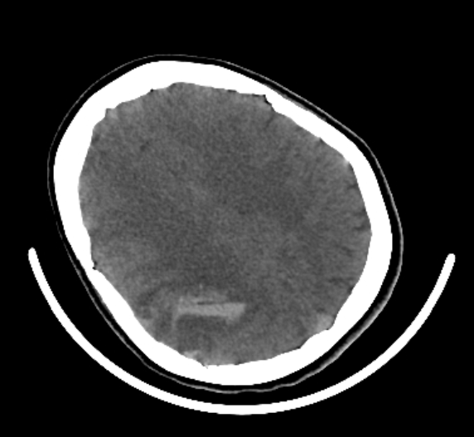
Difüzyon manyetik rezonans görüntülemede arteriyel akut iskemik inme lehine yaygın difüzyon kısıtlanması saptanmadı. Hemorajik alanlar ve çevresinde sınırlı difüzyon kısıtlanmaları izlendi.
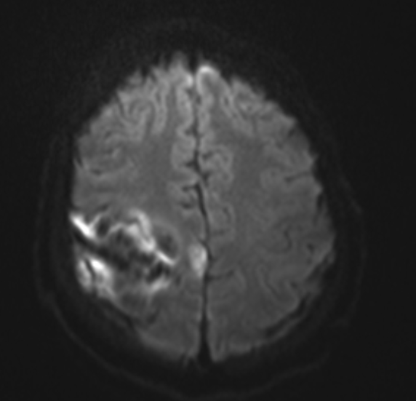
Serebral venöz tromboz şüphesi üzerine yapılan MR venografide superior sagittal sinüste tromboz ile uyumlu sinyal değişiklikleri saptandı ve SVT tanısı doğrulandı.
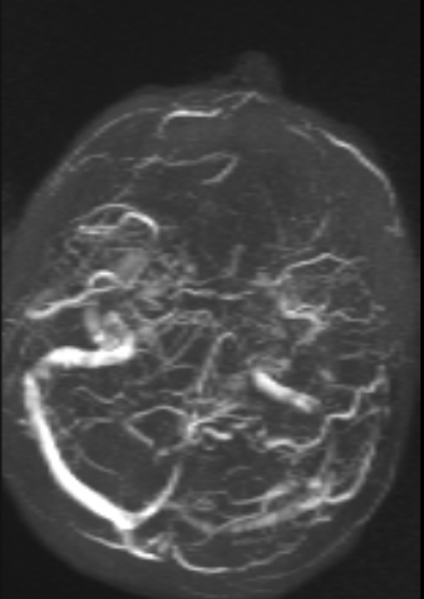
Hastanın eşlik eden ciddi hipoksemi ve solunum sıkıntısı nedeniyle toraks BT gerçekleştirildi. Bilateral interseptal kalınlaşma, yaygın buzlu cam dansiteleri ve sağda belirgin olmak üzere bilateral plevral efüzyon saptandı. Bulgular akut pulmoner ödem ile uyumlu değerlendirildi.
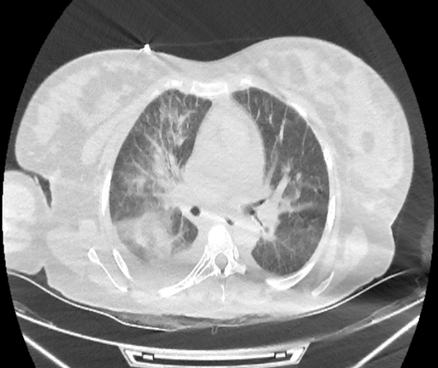
Kardiyak değerlendirme amacıyla yapılan ekokardiyografik inceleme, hastanın pozisyon verilememesi nedeniyle suboptimal olmakla birlikte LVEF %35–40 olarak ölçüldü. İkinci derece mitral yetersizlik ve birinci-ikinci derece triküspit yetersizliği saptandı. İntrakardiyak trombüs veya vejetasyon izlenmedi. Klinik ve ekokardiyografik bulgular birlikte değerlendirilerek postpartum kardiyomiyopati düşünüldü.
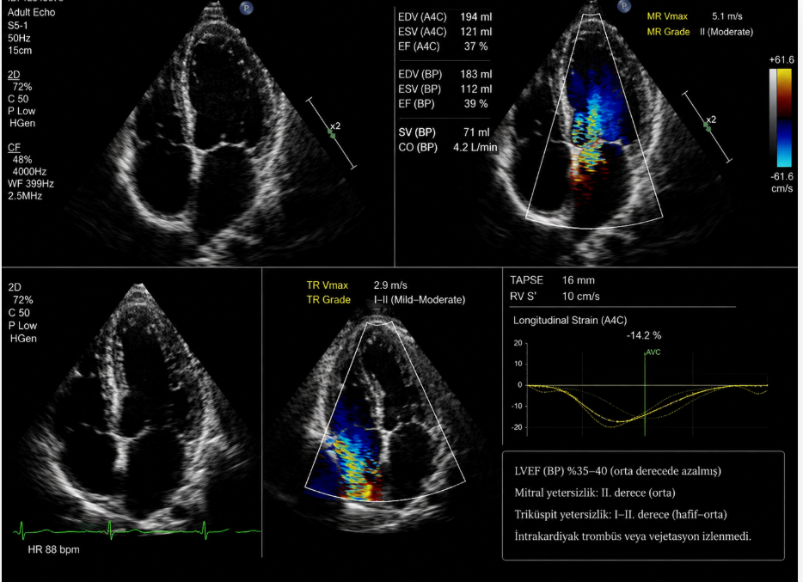
Hastanın klinik, laboratuvar ve görüntüleme bulguları birlikte değerlendirildiğinde; postpartum kardiyomiyopati zemininde gelişen superior sagittal sinüs trombozu, SVT'ye bağlı hemorajik venöz infarkt ve akut pulmoner ödem tanıları konuldu.

Tartışma
Postpartum dönem, gebelik sırasında gelişen artmış koagülasyon aktivitesi, doğal antikoagülan sistemlerdeki değişiklikler ve azalmış fibrinoliz nedeniyle hiperkoagülabilitenin devam ettiği ve venöz tromboemboli riskinin arttığı bir dönemdir.(3) Sezaryen doğum ve doğum sonrası immobilizasyon gibi ek klinik risk faktörleri, postpartum dönemde mevcut olan hiperkoagülabiliteye eklenerek venöz tromboemboli riskini artırabilmektedir.(4)
Serebral venöz tromboz postpartum dönemde nadir görülmekle birlikte önemli bir nörolojik acildir. Klinik bulguların nonspesifik olması nedeniyle tanı gecikebilir. Baş ağrısı en sık semptom olmakla birlikte fokal nörolojik defisit, bilinç değişikliği, nöbet ve koma görülebilir. Venöz drenajın bozulmasına bağlı gelişen venöz hipertansiyon ve venöz infarkt, hemorajik dönüşüm veya intrakraniyal kanama ile komplike olabilir.
Postpartum kardiyomiyopati, özellikle doğum sonrası dönemde açıklanamayan dispne, taşikardi ve sıvı retansiyonu/pulmoner konjesyon bulguları ile ortaya çıkabilen bir kalp yetersizliği tablosudur. Sol ventrikül sistolik fonksiyonundaki belirgin azalma, kardiyak debide düşüş ve venöz konjesyon ile sonuçlanabilir.(5) Bu durum, postpartum dönemin mevcut hiperkoagülabilitesi ile birlikte değerlendirildiğinde tromboembolik komplikasyon gelişimine katkıda bulunabilecek bir faktör olarak düşünülebilir.
Sunulan olguda LVEF'nin %35–40 olması, pulmoner konjesyon ve plevral efüzyon ile birlikte değerlendirildiğinde PPKM tanısını desteklemekteydi. Aynı hastada superior sagittal sinüs trombozu ve buna bağlı hemorajik venöz infarkt saptanması, klinik tablonun yalnızca kardiyak veya nörolojik bir patoloji ile açıklanamayacağını göstermektedir.
Bu olguda dikkat çekici bir diğer bulgu, troponin yüksekliği ile birlikte ciddi hipoksemi ve pulmoner ödemin bulunmasıdır. Kardiyak ve nörolojik patolojilerin eş zamanlı değerlendirilmesi, hastanın tanı ve tedavi sürecinde kritik önem taşımıştır.
Literatürde postpartum dönemde SVT ve PPKM'nin ayrı ayrı görüldüğü olgular bulunmakla birlikte, PPKM, superior sagittal sinüs trombozu, hemorajik venöz infarkt ve akut pulmoner ödemin aynı klinik tabloda birlikte ortaya çıkması oldukça nadirdir.

Sonuç
Postpartum dönemde gelişen bilinç değişikliği, fokal nörolojik defisit, senkop, dispne, taşikardi ve hipoksemi gibi bulgular ciddi multisistemik komplikasyonların habercisi olabilir. Bu hastalarda yalnızca obstetrik nedenler değil, serebral venöz tromboz ve postpartum kardiyomiyopati gibi nadir ancak yaşamı tehdit eden durumlar da akılda tutulmalıdır.
Özellikle nörolojik bulguların eşlik ettiği postpartum hastalarda serebral venöz tromboz açısından uygun nörogörüntüleme yapılması; dispne ve hipoksemi varlığında ise kardiyak ve pulmoner değerlendirme gerçekleştirilmesi erken tanı açısından önemlidir.
Postpartum dönemde nörolojik ve kardiyopulmoner semptomların birlikte bulunması, birden fazla hayatı tehdit eden patolojinin eş zamanlı gelişebileceği düşünülerek multisistemik yaklaşımı gerektirmektedir.
Anahtar Kelimeler: Postpartum kardiyomiyopati, serebral venöz tromboz, superior sagittal sinüs trombozu, hemorajik venöz infarkt, intraserebral kanama, pulmoner ödem, postpartum dönem.
Kaynakça
- Johann Bauersachs , Tobias König , Peter van der Meer , Mark C. Petrie , Denise Hilfiker-Kleiner , Amam Mbakwem , Righab Hamdan , Alice M. Jackson , Paul Forsyth , Rudolf A. de Boer , Christian Mueller , Alexander R. Lyon , Lars H. Lund , Massimo F. Piepoli , Stephane Heymans , Ovidiu Chioncel , Stefan D. Anker , Piotr Ponikowski , Petar M. Seferovic , Mark R. Johnson , Alexandre Mebazaa , Karen Sliwa
- José M Ferro, Marie-Germaine Bousser, Patrícia Canhão, Jonathan M Coutinho, Isabelle Crassard, Francesco Dentali, Matteo di Minno, Alberto Maino, Ida Martinelli, Florian Masuhr, Diana Aguiar de Sousa, Jan Stam, for the European Stroke Organization, European Stroke Organization guideline for the diagnosis and treatment of cerebral venous thrombosis – Endorsed by the European Academy of Neurology, European Stroke Journal, Volume 2, Issue 3, 1 September 2017, Pages 195–221, https://doi.org/10.1177/2396987317719364
- Othman M, Pradhan A. Laboratory Testing of Hemostasis in Pregnancy: A Brief Overview. Methods Mol Biol. 2023;2663:111-125. doi: 10.1007/978-1-0716-3175-1_7. PMID: 37204707.
- Bates SM, Rajasekhar A, Middeldorp S, et al. American Society of Hematology 2018 guidelines for management of venous thromboembolism: venous thromboembolism in the context of pregnancy. Blood Adv. 2018;2(22):3317-3359. doi: 10.1182/bloodadvances.2018024802
- Bauersachs J, König T, van der Meer P, Petrie MC, Hilfiker-Kleiner D, Mbakwem A, Hamdan R, Jackson AM, Forsyth P, de Boer RA, Mueller C, Lyon AR, Lund LH, Piepoli MF, Heymans S, Chioncel O, Anker SD, Ponikowski P, Seferovic PM, Johnson MR, Mebazaa A, Sliwa K. Pathophysiology, diagnosis and management of peripartum cardiomyopathy: a position statement from the Heart Failure Association of the European Society of Cardiology Study Group on peripartum cardiomyopathy. Eur J Heart Fail. 2019 Jul;21(7):827-843. doi: 10.1002/ejhf.1493. Epub 2019 Jun 27. PMID: 31243866.

YAZAR DİZİNİ / AUTHOR INDEX
Aşağıdaki dizinde sözlü sunucudan bağımsız olarak kabul edilmiş tam metinlerdeki tüm yazarlar yer almaktadır.
Yazar | Bildiri(ler)
Ahmet Ocak | SS-007
Duygu Özkan Yaşargün | SS-002
Esat Barut | SS-005
Fatma Taş | SS-007
Gülendam Alkan | SS-005
Hasan Büyükaslan | SS-004, SS-006
Hülya Abalı | SS-003
İbrahim Halil Yasak | SS-007
İlhami Yüksel | SS-006
Mehmet Gün | SS-001
Talha Gökber Durmuş | SS-004

KAYNAK PROGRAM / ORIGINAL SCIENTIFIC PROGRAM
Aşağıda kongre dönemine ait resmî bilimsel programın altı sayfalık tarihsel nüshası bulunmaktadır. Bu ilk nüshada sözlü bildiri oturumu için tek başkan listelenmiştir; 23 Ekim 2026 tarihli Bilim ve Yayın Kurulu onaylı düzeltmede Mehmet Tatlı ikinci oturum başkanı olarak eklenmiştir. Tam metinlerin yazar sıraları sunucu listesinden bağımsızdır.

EMDATE 6 — Program, sayfa 1
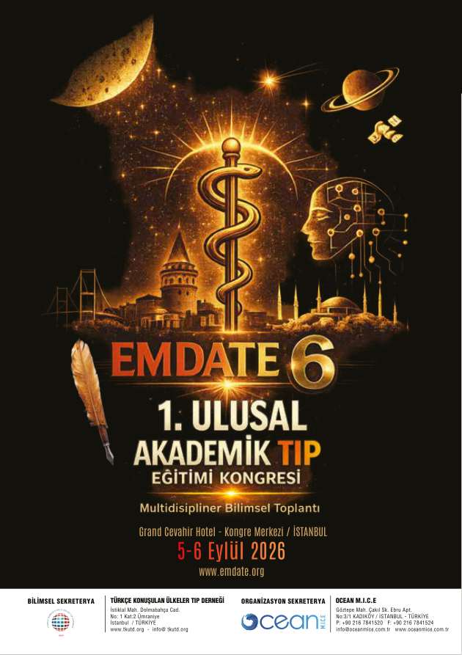

EMDATE 6 — Program, sayfa 2
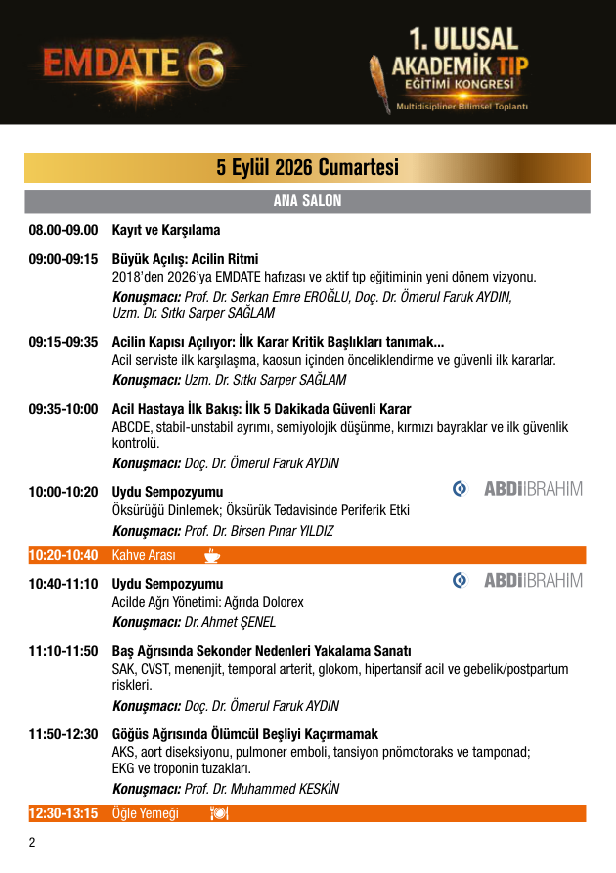

EMDATE 6 — Program, sayfa 3
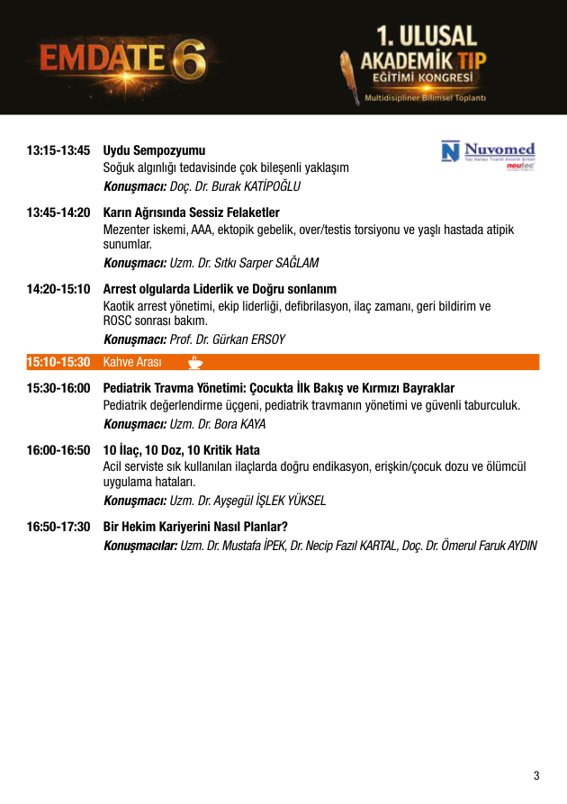

EMDATE 6 — Program, sayfa 4
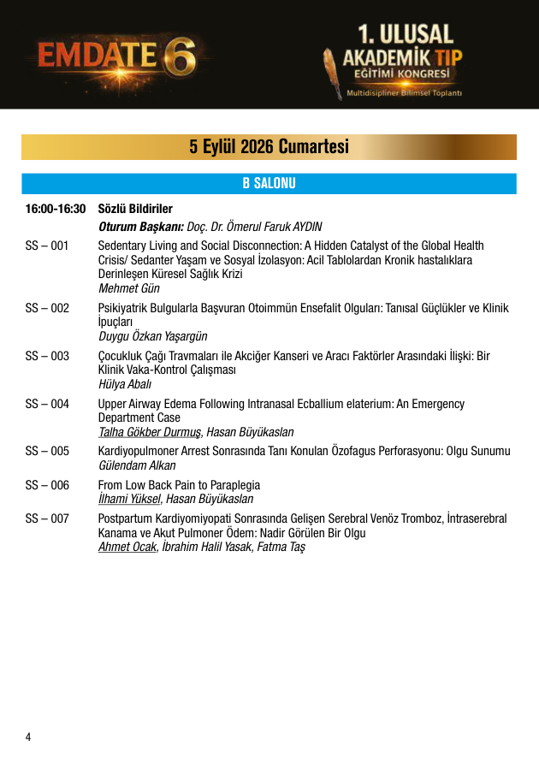

EMDATE 6 — Program, sayfa 5
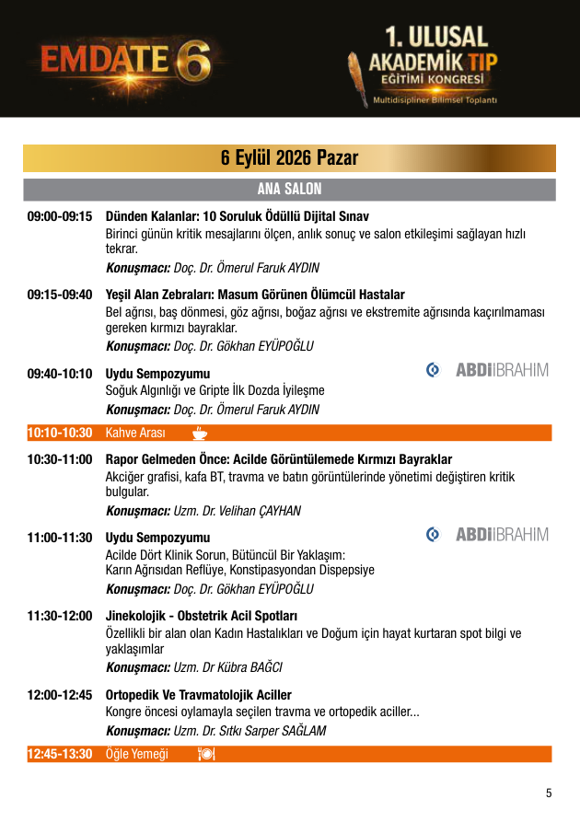

EMDATE 6 — Program, sayfa 6
